


Clean public areas, facilities and equipment
D1.HHK.CL3.02
Trainee Manual




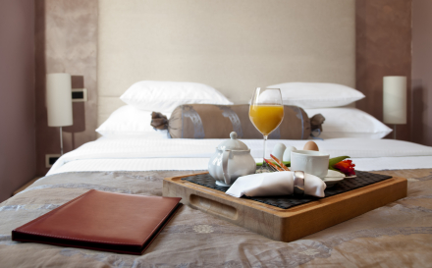

Clean public areas, facilities and equipment

D1.HHK.CL3.02

Trainee Manual





Project Base
William Angliss Institute of TAFE
555 La Trobe Street
Melbourne 3000 Victoria
Telephone: | (03) 9606 2111
Facsimile: | (03) 9670 1330
Acknowledgements
Project Director: | Wayne Crosbie
Chief Writer: | Alan Hickman
Subject Writer: | Nick Hyland
Project Manager | Alan Maguire
Editor: | Jim Irwin
DTP/Production | Daniel Chee, Mai Vu, Jirayu Thangcharoensamut, Kaly Quach

The Association of Southeast Asian Nations (ASEAN) was established on 8 August 1967. The Member States of the Association are Brunei Darussalam, Cambodia, Indonesia, Lao PDR, Malaysia, Myanmar, Philippines, Singapore, Thailand and Viet Nam.
The ASEAN Secretariat is based in Jakarta, Indonesia.
General Information on ASEAN appears online at the ASEAN Website: www.asean.org.
All text is produced by William Angliss Institute of TAFE for the ASEAN Project on “Toolbox Development for Priority Tourism Labour Division”.
This publication is supported by the Australian Government’s aid program through the ASEAN-Australia Development Cooperation Program Phase II (AADCP II).
Copyright: Association of Southeast Asian Nations (ASEAN) 2012.
All rights reserved.
Disclaimer
Every effort has been made to ensure that this publication is free from errors or omissions. However, you should conduct your own enquiries and seek professional advice before relying on any fact, statement or matter contained in this book. The ASEAN Secretariat and William Angliss Institute of TAFE are not responsible for any injury, loss or damage as a result of material included or omitted from this course. Information in this module is current at the time of publication. Time of publication is indicated in the date stamp at the bottom of each page.
Some images appearing in this resource have been purchased from stock photography suppliers Shutterstock and iStockphoto and other third party copyright owners and as such are non-transferable and non-exclusive. Clip arts, font images and illustrations used are from the Microsoft Office Clip Art and Media Library. Some images have been provided by and are the property of William Angliss Institute.
Additional images have been sourced from Flickr and SXC and are used under Creative Commons licence: http://creativecommons.org/licenses/by/2.0/deed.en

File name: TM_Clean_public_areas_facilities_&_equipt_refined





Table of Contents
Introduction to trainee manual 1
Unit descriptor 3
Assessment matrix 7
Glossary 11
Introduction 13
Element 1: Apply leather upholstery cleaning techniques 53
Element 2: Apply fabric upholstery cleaning techniques 59
Element 3: Apply glass surfaces cleaning techniques 67
Element 4: Apply ceilings, surfaces and fittings cleaning techniques 75
Element 5: Apply wet area cleaning techniques 85
Element 6: Apply pressure washing techniques 91
Element 7: Apply high level cleaning techniques 97
Presentation of written work 103
Recommended reading 105
Trainee evaluation sheet 107
Trainee self-assessment checklist 109

Introduction to trainee manual

To the Trainee
Congratulations on joining this course. This Trainee Manual is one part of a ‘toolbox’ which is a resource provided to trainees, trainers and assessors to help you become competent in various areas of your work.
The ‘toolbox’ consists of three elements:
- A Trainee Manual for you to read and study at home or in class
- A Trainer Guide with Power Point slides to help your Trainer explain the content of the training material and provide class activities to help with practice
- An Assessment Manual which provides your Assessor with oral and written questions and other assessment tasks to establish whether or not you have achieved competency.
The first thing you may notice is that this training program and the information you find in the Trainee Manual seems different to the textbooks you have used previously. This is because the method of instruction and examination is different. The method used is called Competency based training (CBT) and Competency based assessment (CBA). CBT and CBA is the training and assessment system chosen by ASEAN (Association of South-East Asian Nations) to train people to work in the tourism and hospitality industry throughout all the ASEAN member states.
What is the CBT and CBA system and why has it been adopted by ASEAN?
CBT is a way of training that concentrates on what a worker can do or is required to do at work. The aim is of the training is to enable trainees to perform tasks and duties at a standard expected by employers. CBT seeks to develop the skills, knowledge and attitudes (or recognise the ones the trainee already possesses) to achieve the required competency standard. ASEAN has adopted the CBT/CBA training system as it is able to produce the type of worker that industry is looking for and this therefore increases trainees chances of obtaining employment.
CBA involves collecting evidence and making a judgement of the extent to which a worker can perform his/her duties at the required competency standard. Where a trainee can already demonstrate a degree of competency, either due to prior training or work experience, a process of ‘Recognition of Prior Learning’ (RPL) is available to trainees to recognise this. Please speak to your trainer about RPL if you think this applies to you.
What is a competency standard?
Competency standards are descriptions of the skills and knowledge required to perform a task or activity at the level of a required standard.
242 competency standards for the tourism and hospitality industries throughout the ASEAN region have been developed to cover all the knowledge, skills and attitudes required to work in the following occupational areas:
- Housekeeping
- Food Production
- Food and Beverage Service
- Front Office
- Travel Agencies
- Tour Operations.
All of these competency standards are available for you to look at. In fact you will find a summary of each one at the beginning of each Trainee Manual under the heading ‘Unit Descriptor’. The unit descriptor describes the content of the unit you will be studying in the Trainee Manual and provides a table of contents which are divided up into ‘Elements’ and ‘Performance Criteria”. An element is a description of one aspect of what has to be achieved in the workplace. The ‘Performance Criteria’ below each element details the level of performance that needs to be demonstrated to be declared competent.
There are other components of the competency standard:
- Unit Title: statement about what is to be done in the workplace
- Unit Number: unique number identifying the particular competency
- Nominal hours: number of classroom or practical hours usually needed to complete the competency. We call them ‘nominal’ hours because they can vary e.g. sometimes it will take an individual less time to complete a unit of competency because he/she has prior knowledge or work experience in that area.
The final heading you will see before you start reading the Trainee Manual is the ‘Assessment Matrix’. Competency based assessment requires trainees to be assessed in at least 2 – 3 different ways, one of which must be practical. This section outlines three ways assessment can be carried out and includes work projects, written questions and oral questions. The matrix is designed to show you which performance criteria will be assessed and how they will be assessed. Your trainer and/or assessor may also use other assessment methods including ‘Observation Checklist’ and ‘Third Party Statement’. An observation checklist is a way of recording how you perform at work and a third party statement is a statement by a supervisor or employer about the degree of competence they believe you have achieved. This can be based on observing your workplace performance, inspecting your work or gaining feedback from fellow workers.
Your trainer and/or assessor may use other methods to assess you such as:
- Journals
- Oral presentations
- Role plays
- Log books
- Group projects
- Practical demonstrations.
Remember your trainer is there to help you succeed and become competent. Please feel free to ask him or her for more explanation of what you have just read and of what is expected from you and best wishes for your future studies and future career in tourism and hospitality.

Unit descriptor
Clean public areas, facilities and equipment
This unit deals with the skills and knowledge required to Clean public areas, facilities and equipment in a range of settings within the hotel and travel industries workplace context.
Unit Code:
D1.HHK.CL3.02
Nominal Hours:
60 hours

Element 1: Apply leather upholstery cleaning techniques
Performance Criteria
1.1 Assess leather upholstery to be cleaned
1.2 Select appropriate equipment and chemicals
1.3 Prepare work site
1.4 Clean upholstery
1.5 Tidy work site
1.6 Clean, check and store equipment and chemicals

Element 2: Apply fabric upholstery cleaning techniques
Performance Criteria
2.1 Assess fabric upholstery to be cleaned
2.2 Select appropriate equipment and chemicals
2.3 Prepare work site
2.4 Clean upholstery
2.5 Tidy work site
2.6 Clean, check and store equipment and chemicals

Element 3: Apply glass surfaces cleaning techniques
Performance Criteria
3.1 Assess glass areas to be cleaned
3.2 Select appropriate equipment and chemicals
3.3 Prepare work site
3.4 Clean glass areas
3.5 Tidy work site
3.6 Clean, check and store equipment and chemicals

Element 4: Apply ceilings, surfaces and fittings cleaning techniques
Performance Criteria
4.1 Assess ceilings, surfaces and fittings areas to be cleaned
4.2 Select appropriate equipment and chemicals
4.3 Prepare work site
4.4 Clean ceilings, surfaces and fittings
4.5 Tidy work site
4.6 Clean, check and store equipment and chemicals

Element 5: Apply wet area cleaning techniques
Performance Criteria
5.1 Assess wet areas to be cleaned
5.2 Select appropriate equipment and chemicals
5.3 Prepare work site
5.4 Clean wet areas
5.5 Tidy work site
5.6 Clean, check and store equipment and chemicals

Element 6: Apply pressure washing techniques
Performance Criteria
6.1 Assess area to be pressure washed
6.2 Select appropriate equipment and chemicals
6.3 Prepare work site
6.4 Clean areas using pressure washer
6.5 Tidy work site
6.6 Clean, check and store equipment and chemicals

Element 7: Apply high level cleaning techniques
Performance Criteria
7.1 Assess high level areas to be cleaned
7.2 Select appropriate equipment and chemicals
7.3 Prepare work site
7.4 Clean high level areas
7.5 Tidy work site
7.6 Clean, check and store equipment and chemicals

Assessment matrix
Showing mapping of Performance Criteria against Work Projects, Written Questions and Oral Questions
The Assessment Matrix indicates three of the most common assessment activities your Assessor may use to assess your understanding of the content of this manual and your performance - Work Projects, Written Questions and Oral Questions. It also indicates where you can find the subject content related to these assessment activities in the Trainee Manual (i.e. under which element or performance criteria). As explained in the Introduction, however, the assessors are free to choose which assessment activities are most suitable to best capture evidence of competency as they deem appropriate for individual students.
 |  |  | Work Projects | Written Questions | Oral Questions
Element 1: Apply leather upholstery cleaning techniques
1.1 | Assess leather upholstery to be cleaned |  | 1.1 | 1 | 1
1.2 | Select appropriate equipment and chemicals |  | 1.2 | 2 | 2
1.3 | Prepare work site |  | 1.3 | 3 | 3
1.4 | Clean upholstery |  | 1.4 | 4 | 4
1.5 | Tidy work site |  | 1.5 | 5 | 5
1.6 | Clean, check and store equipment and chemicals |  | 1.6 | 6 | 6
Element 2: Apply fabric upholstery cleaning techniques
2.1 |  | Assess fabric upholstery to be cleaned | 2.1 | 7 | 7
2.2 |  | Select appropriate equipment and chemicals | 2.2 | 8 | 8
2.3 |  | Prepare work site | 2.3 | 9 | 9
2.4 |  | Clean upholstery | 2.4 | 10 | 10
2.5 |  | Tidy work site | 2.5 | 11 | 11
2.6 |  | Clean, check and store equipment and chemicals | 2.6 | 12 | 12
Element 3: Apply glass surfaces cleaning techniques
3.1 | Assess glass areas to be cleaned |  | 3.1 | 13 | 13
3.2 | Select appropriate equipment and chemicals |  | 3.2 | 14 | 14
3.3 | Prepare work site |  | 3.3 | 15 | 15
3.4 | Clean glass areas |  | 3.4 | 16 | 16
3.5 | Tidy work site |  | 3.5 | 17 | 17
3.6 | Clean, check and store equipment and chemicals |  | 3.6 | 18 | 18
Element 4: Apply ceilings, surfaces and fittings cleaning techniques
4.1 |  | Assess ceilings, surfaces and fittings areas to be cleaned | 4.1 | 19 | 19
4.2 |  | Select appropriate equipment and chemicals | 4.2 | 20 | 20
4.3 |  | Prepare work site | 4.3 | 21 | 21
4.4 |  | Clean ceilings, surfaces and fittings | 4.4 | 22 | 22
4.5 |  | Tidy work site | 4.5 | 23 | 23
4.6 |  | Clean, check and store equipment and chemicals | 4.6 | 24 | 24
Element 5: Apply wet area cleaning techniques
5.1 | Assess wet areas to be cleaned |  | 5.1 | 25 | 25
5.2 | Select appropriate equipment and chemicals |  | 5.2 | 26 | 26
5.3 | Prepare work site |  | 5.3 | 27 | 27
5.4 | Clean wet areas |  | 5.4 | 28 | 28
5.5 | Tidy work site |  | 5.5 | 29 | 29
5.6 | Clean, check and store equipment and chemicals |  | 5.6 | 30 | 30
Element 6: Apply pressure washing techniques
6.1 |  | Assess area to be pressure washed | 6.1 | 31 | 31
6.2 |  | Select appropriate equipment and chemicals | 6.2 | 32 | 32
6.3 |  | Prepare work site | 6.3 | 33 | 33
6.4 |  | Clean areas using pressure washer | 6.4 | 34 | 34
6.5 |  | Tidy work site | 6.5 | 35 | 35
6.6 |  | Clean, check and store equipment and chemicals | 6.6 | 36 | 36
Element 7: Apply high level cleaning techniques
7.1 | Assess high level areas to be cleaned |  | 7.1 | 37 | 37
7.2 | Select appropriate equipment and chemicals |  | 7.2 | 38 | 38
7.3 | Prepare work site |  | 7.3 | 39 | 39
7.4 | Clean high level areas |  | 7.4 | 40 | 40
7.5 | Tidy work site |  | 7.5 | 41 | 41
7.6 | Clean, check and store equipment and chemicals |  | 7.6 | 42 | 42

Glossary
Term | Explanation
Chemical | A product, normally in liquid format, used to clean a surface
Clean | Free from dirt; unsoiled; unstained
Deodoriser | To remove, disguise, or absorb the odour of, esp. when unpleasant
Deep cleaning | Substantial cleaning used to remove more than surface dirt, stains and grime
Defect | A shortcoming, fault, or imperfection
Disinfectant | Any chemical agent used chiefly on inanimate objects to destroy or inhibit the growth of harmful organisms
Fabric | A cloth made by weaving, knitting, or felting fibres
Fittings | Anything provided as equipment, parts, supply
Furnishings | Furniture, carpeting, etc., for a house or room
Furniture | The movable articles, as tables, chairs, desks or cabinets, required for use or ornament in an area
Garbage | Litter, refuse, junk, rubbish
Housekeeping | The maintenance of a house or domestic establishment
Hygiene | A condition or practice conducive to the preservation of health, as cleanliness
Laundry | Articles of clothing, linens, etc that have been or are to be washed
Leather | The skin of an animal, with the hair removed, prepared for use by tanning or a similar process designed to preserve it against decay and make it pliable or supple when dry
Manual handling | The act of pushing, pulling or lifting
OSH | Occupational Safety and Health. In some countries the term OHS ‘Occupational Health and Safety’ is used. The concept is identical and relates to workplace safety and health policies, procedures and practices
Policy | A rule, a definite course of action
Polish | To make smooth and glossy, especially by rubbing or friction
PPE | Personal protection equipment
Preparatory cleaning functions | Activities to be completed before actual cleaning takes place
Procedure | A particular course or mode of action
Public area | Any location within a hotel that all customers have access to and can use, not for the exclusive use of one particular customer
Safety | The state of being safe; freedom from the occurrence or risk of injury, danger, or loss
Trolley | A transport vehicle used in housekeeping to move supplies from area to area
Upholstery | The materials used to cushion and cover furniture

Introduction

One of the basic requirements that a customer of a hospitality business has is that an organisation is clean and tidy.
Whilst it is essential that a premise looks clean, tidy and aesthetically pleasing, it is more important that it is actually free from dangers that can pose a hygiene or safety risk.
It is expected that the level and detail of cleanliness not only matches but exceeds that found in a normal household.
It doesn’t matter what products are supplied or how great services are, if a venue if not hygienically clean, customers will not come. Understandably most people consider their health a primary concern.
This manual will explore in detail how to clean and maintain public areas, facilities and equipment within a hospitality outlet.
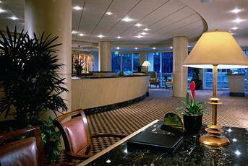
Before we can start to discuss cleaning methods involved, it is important to identify and discuss these three key terms:
- Public areas
- Facilities
- Equipment.

Public areas
A public space is any area within a hospitality organisation that is readily available for all customers to enjoy.
It is different from a ‘private’ area which is for the exclusive use of a customer. The most common example is a guest room.
What is defined as a ‘private’ or ‘public’ area will differ between organisations, depending on the level of access and exclusivity it wishes to place on an area.

For the purpose of this manual the following areas are normally considered ‘public’ areas of a hospitality organisation:
- Lobby
- Restaurants
- Bars
- Outlet shops
- Elevators
- Public toilets
- Corridors
- Gardens
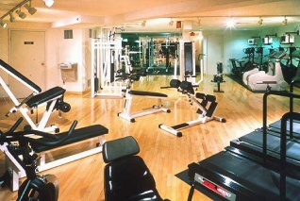
- Swimming pools
- Gymnasiums
- Play areas
- Car parks.

Facilities
Facilities are aspects of products and services within these public areas.

It can include:
- Furniture commonly refers to items in the room that are movable including tables, chairs and sundecks
- Fixtures refer to items that are attached including heaters, air conditioners and lights
- Fittings refer to taps, pipes and electrical aspects of a public space.

Equipment
Equipment is defined as the items within the public area that are used, their by customers or staff.
Examples of equipment can used by staff include:

- Buffet areas
- Kitchen equipment.
Examples of leisure equipment used by customers include:
- Games – board games, ping pong tables
- Sporting goods – golf clubs
- Gym equipment – water tanks, weights and machines
- Pool equipment – inflatable equipment and balls
- Leisure machinery - jet skis, boats
- Playground equipment.
For the purpose of this manual, cleaning equipment used to clean public areas, facilities and equipment will not be included in this category.

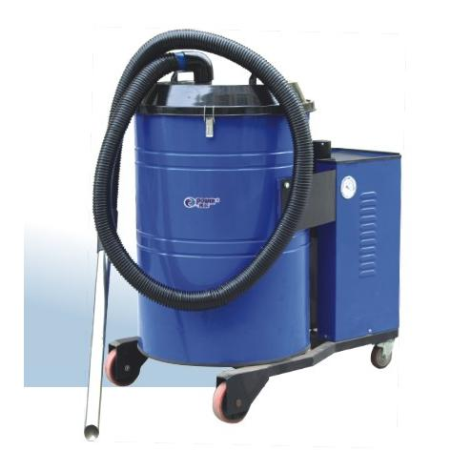
Types of cleaning equipment
The type of cleaning equipment found in businesses will vary.
Some premises have just the basics. Many establishments will have only ‘domestic’ cleaning equipment, normally suitable for homes, rather than commercial or industrial cleaning equipment.
Generally, commercial or industrial equipment is better because it is:
- Sturdier
- Larger capacity
- Fitted with larger electric motors.
Other places boast an extensive range of the latest cleaning equipment with the ‘correct’ item for every cleaning job that needs doing.
Essentially, the surface to be cleaned and the nature of the cleaning to be done will determine what is to be used.
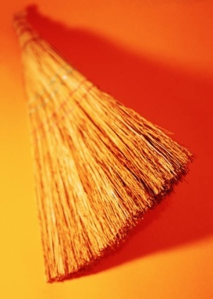
In order to make this manual more user friendly and to avoid repetition of information, this section will include a description of equipment that is commonly used to clean all cleaning surfaces. Each section within the manual will identify equipment specific to a particular type of surface or cleaning required.
Specialist equipment will be used where special situations exist. For example, a property with a large outside area may have a motorised cleaner that is not necessary in a small travel agency that only has internal areas that require cleaning.
The cleaning storeroom
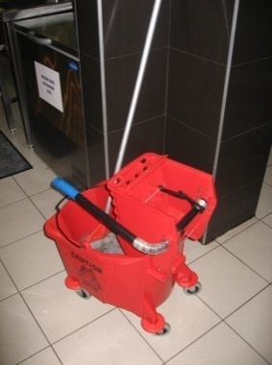
Cleaning equipment is usually kept in a specifically dedicated storage area. This may be a purpose-built cleaning storeroom where equipment, utensils, cleaning chemicals and protective clothing is kept.
Alternatively, equipment may be kept in an assortment of cupboards or other locations around the premises as space allows.
The following gives a representative list of the cleaning equipment that the majority of properties will use.

Manual Cleaning Equipment
This section will explore the range of manual cleaning equipment commonly used to clean public areas, facilities and equipment.
Equipment that needs to be correctly selected and prepared before it is used may include:
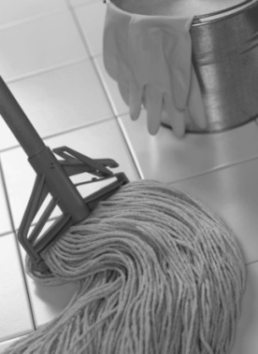
Mops
Mops may include wet mops for washing floors and dry mops for polishing and dusting, depending on the areas to be cleaned.
Mops are generally made from cotton or cotton/polyester blends.
The three main types of mops are:
- Dusting mops – to clean skirting boards and polished surfaces
- Polishing mops – for buffing and polishing
- Washing mops – to wash floor surfaces or apply sealant to floors that have been stripped and need to be re-sealed.
Ensure the mop head looks presentable as guests will be able to see this and may infer a lack of cleanliness in other or all cleaning from seeing a dirty mop head. Also ensure it has been sanitised to kill bacteria.
Visit:
- http://www.globalsources.com/manufacturers/Cleaning-Mop.html
- http://www.santosimports.com.au/cateringproducts.php?cat=Cleaning&page=
36&limit=12.
Brooms and brushes
Brooms and brushes can be made from a variety of materials, ranging from straw to a synthetic coarse bristle-like material. Their purpose is to remove dust, dirt and grime from surfaces.
They can come in all sizes and shapes, depending on the purpose they were designed for.
These should be sufficient in number as dictated by the establishment, clean, and sufficiently bristled.
The most common types of brooms and brushes are:
- Carpet brush
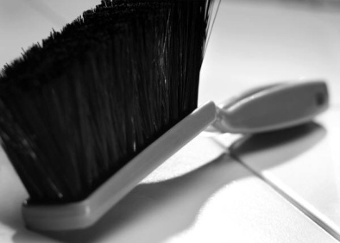
- Scrubbing brush
- Sink brush
- Silk brush
- Toilet brush
- Wall brush
- Soft broom
- Hand brush.
Not all types will be required. It will depend on the facilities to be cleaned.
A standard item is a dust pan and brush set for cleaning up small spills etc.
Have a look at:
- http://clickclack.com/bw/index.asp
- http://www.ravibrush.com/Australia-Range.html.
Cloths and sponges
Cloths and sponges are used to clean a variety of surfaces.
Sponges are used for damp cleaning needs and cloths are used for cleaning, polishing and dusting.
They can be made from a variety of materials, but are generally lint-free.
They are used with a cleaning agent.
Some cloths are made from material and some are disposable/paper-based.
Go to:
- http://www.seton.net.au/templates/cleaning_toiletpaper.cfm.
Buckets
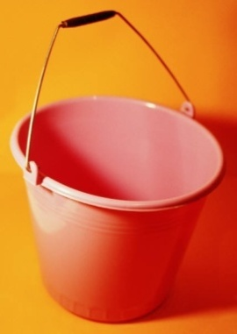
Buckets can come in a variety of shapes, sizes and styles and are generally made from either galvanised steel or plastic.
Some buckets have wheels for ease of mobility, others only have a handle.
Buckets are used to hold water and cleaning agents.
Mop buckets feature rollers to remove excess water from the mop head prior to use.
Cleaning equipment also normally includes some smaller plastic bucket-type containers used to hold cleaning materials, cloths, and chemicals etc. which are and used to carry items around and into rooms.
Buckets may be required for wet mopping and most room servicing trolleys will also feature a couple of plastic bucket-type containers used to hold cleaning materials, cloths, chemicals and used to carry items into a guest room
These should be fully operational, not leaking, easy to operate, and not smelly.
- Visit http://www.masteraustralia.com.au/ and click on ‘Buckets’ in the left-hand side ‘Browse Catalogue’. This site can be used to look at many of the housekeeping mentioned in these notes. It is worth bookmarking for future reference.

Garbage receptacles
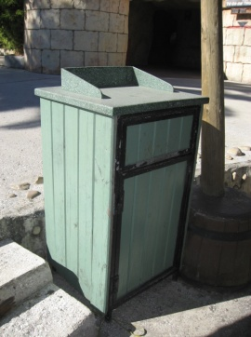
Nearly all cleaning tasks will require you to gather and dispose of debris, rubbish, waste etc so most cleaning tasks will necessitate the use of some form of waste receptacle.
The ‘receptacle’ may be:
- A solid item –such as a bin
- A disposable plastic bag – usually heavy-duty
- A bin liner placed inside a garbage receptacle that is built-in to a cleaning trolley.
All bins need to be cleaned to maintain the ‘clean’ image that every business wants to project. Just because they are bins doesn’t allow you to let them get, or use them when they are, dirty.
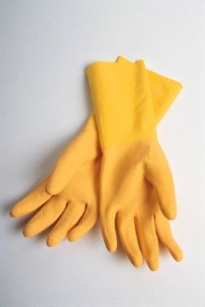
Protective gloves
A good supply of disposable gloves should be available to all cleaning staff. Specific house requirements in relation to individual Occupational Safety and Health (OSH) issues may require other, more substantial protective clothing (including gloves) be worn.
It is standard procedure in all premises that cleaners wear protective gloves when cleaning and handling chemicals.
- Visit http://www.masteraustralia.com.au/ and click on ‘Gloves’ in the left-hand side ‘Browse Catalogue’.
Warning signs
These are safety signs used when a public area is being cleaned to:
- Warn customers of the danger or when nominated back-of-house areas are being cleaned
- Warn staff, delivery drivers, repair people who are on the premises.
It may be standard procedures that they are displayed whenever cleaning duties are being undertaken, regardless of location and regardless of the type of cleaning.
Examples of these can be seen at:
- http://www.hostdirect.com.au/listProduct/Cleaning/Floor+Signs/.

Personal protective equipment
Employers are under a legal obligation to supply necessary protective clothing and equipment to staff when it is appropriate as part of the response to an identified workplace risk/hazard.
Staff are under an obligation to wear and use this equipment and clothing when required and as instructed.
Protective clothing and equipment is rarely acceptable as the total response to a risk/hazard.
The industry sometimes uses a term to describe the safety equipment that is available to staff. The term is ‘PPE’ which stands for ‘Personal Protective Equipment and clothing’.
PPE that needs to be used for a job must be supplied and maintained by the establishment – you are not required to provide your own.
PPE may include:
- Overalls, jackets and aprons (material aprons and PVC aprons)

- Thick rubber gloves, PVC gloves, gauntlets
- Cotton glove inserts
- Breathing apparatus
- Waterproof clothing and footwear/rubber boots
- Eye protection, safety glasses
- Enclosed shoes and steel-capped boots
- Safety hats/hard hats, headwear and helmets
- Goggles and face masks
- Uniform to be worn – which can include long trousers, long-sleeved shirts
- RCD devices – see below
- Where staff are required to work outside in the elements, PPE can include sun hats/broad brimmed hats, sun glasses and sun protection as well as rain coats, warm clothing.
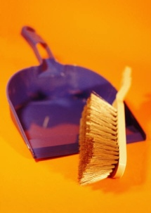
Remember, PPE must be used when and where required by your employer. It is not optional.
Dust pan
A dust pan is vital to collect dirt, dust and rubbish.

Electrically Powered Equipment
The majority of businesses use either industrial or commercial cleaning equipment, but the use of domestic items is also common.
Industrial or commercial items have stronger motors, larger capacities, are more sturdily built.
Vacuum cleaners
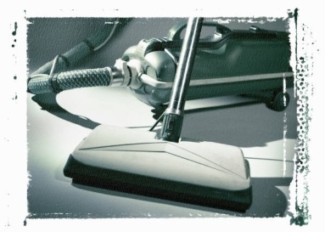
Whatever the shape, size or style of vacuum cleaners, their job is to suck up dust and dirt off floor surfaces and drapes.
Most vacuum cleaners have a variety of attachments designed for specific purposes (such as crevice nozzles).
Vacuum cleaners are available in wet or dry types.
Dry vacuum cleaners can only be used on dry surfaces and to suck up dry material and not liquids.
Wet vacuum cleaners are designed to suck up liquid spills and can be used for wet cleaning of carpets.
Double-check that the vacuum cleaner you intend using is designated as a ‘wet’ vacuum cleaner before using it on liquids: some vacuum cleaners are dual-purpose and can be used on wet or dry surfaces.
‘Back pack’ vacuum cleaners are used in many situations where it would be difficult or time-consuming to use a machine that is pulled along the floor – such as when vacuuming between tables and chairs. A backpack style cleaner also reduces tripping hazards (although the cord still presents a hazard unless a battery-powered unit is being used).
Some companies refer to vacuum cleaners as ‘extractors’.
Have a look at different vacuum cleaner options at:
- http://www.powervac.biz/
- http://www.powersweep.com.au/
- http://www.gepro.com.au/ics/profile.asp
- http://www.nilfisk-advance.com.au/.
Carpet shampoo machines
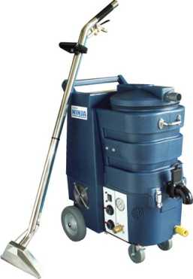
Carpet shampoo machines can also come in a variety of shapes, sizes and styles.
As their name suggests they are used to shampoo, dry-clean or steam clean carpeted surfaces. They may also be referred to as ‘extractors’.
Remember that carpets may be damp or wet after being shampooed (or steamed), so this needs to be taken into consideration before cleaning high traffic areas, both in terms of how the area will look and smell, and from a safety viewpoint.
All carpet shampoo machines must be used in accordance with the manufacturer’s instructions.
Companies that supply vacuum cleaners usually also supply these machines so check out the sites for ‘vacuum cleaners’ listed above as well as:
- http://www.cleanfreak.com/
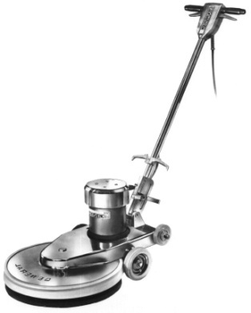
- http://www.davanna.com.au/index1.html.
Polishers
Also known as ‘burnishers’ these machines are used to polish or ‘buff’ floor surfaces – such as polished floors.
Polishing a floor helps resist scratching and enhances appearance.
They come in different sizes to enable access and time-effective polishing in small as well as large areas.
Some include a suction facility that sucks up dust particles during the polishing process: where these exist, filters need to be changed as recommended by the manufacturer, or as readings from equipment gauges dictate.
Scrubbing machines
Scrubbing machines can be used to remove debris from hard surfaces such as tiles and concrete, sealed floors, carpet and other areas such as escalators, entrance matting and travelators.
One main use of a scrubbing machine is where hard floor surfaces need to be stripped and then re-sealed.
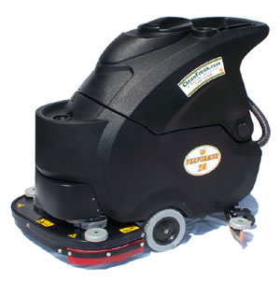
Note that different pads which are normally colour-coded are available for use on different floor surfaces where a variation in stripping level is required. Red is the buffing pad.
Many are integrated with a sweeper which can save time when using the machine by also cleaning up the scrubbed off material.
They are available in a variety of shapes, sizes and styles including walk-behind, ‘pedestrian’ and ride-on models.
They may be electrically-powered or battery powered.

Floor machines
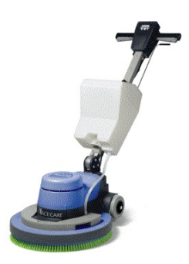
Many machines are available that combine the functions of different machines.
These can be referred to as ‘floor machines’.
The one machine may, then, have the capacity to:
- Scrub
- Polish
- Strip
- Shampoo.

Equipment Complementary Items
Depending on the items required in public areas, it may be the role of the cleaner to ensure that the customer has necessary supplies to use these public areas.
Toiletries
There are items that need to be replenished in public area rest rooms and include:
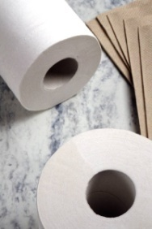
- Toilet paper
- Tissues
- Sanitary bags
- Rubbish bags
- Soap
- Hand towels – cloth or paper
- Shampoo and conditioners.
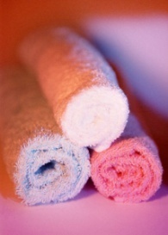
Towels
- Beach towels for the pool
- Towels for public showers.
Replacement items
This can include:
- Batteries to replace worn or stolen batteries in remote control units.
- Light globes to replace lights.
Most properties will get the Maintenance department (or porters) to replace any globes or starters that are in ceiling light fittings.

Check that all equipment is clean and in safe working condition prior to use
Before using any item of cleaning equipment it must be standard practice to check to make sure the item is safe to use, and is in a clean condition.
Manufacturer’s instructions will explain the safety needs regarding individual items such as electrically operated and battery-powered machines but many basic checks apply across all items.
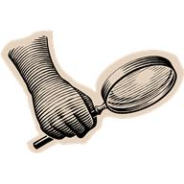
Importance of checks
Checking is important for a number of reasons:
- To avoid mixing chemicals from equipment to equipment. This may damage not only equipment but the surfaces that the chemicals are being applied to
- To avoid transferring dirt or grime from one surface to another. It is a standard requirement that all cleaning items must themselves be cleaned
- To stop transportation of bacteria from one surface to another. The cleaning items, including mops, used in food areas will not only need to be washed but will also need to be sanitised as well
- To avoid accident and injury arising from the use of equipment that is not in safe working order.
What do I need to check?
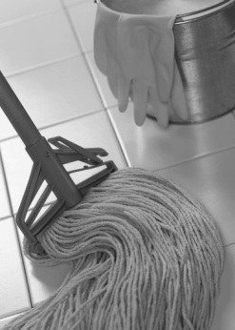
The checks will depend on the item being checked. Safety and cleanliness are prime considerations but you also need to make sure the item itself is ready and able to do the job you expect it to do.
The following is indicative of what you need to check:
- Equipment does not have any jagged parts, edges that can cause injury
- Damage to equipment has not affected its operational safety
- Check and clean the exterior of cleaning equipment – to enhance presentation and project a positive image for the company when seen by patrons. Cleaning equipment must be clean itself
- Ensure mop head looks presentable - customers will be able to see these if you are working in public areas and may infer a lack of cleanliness in other parts of the establishment
- Buckets should be free of leaks, not smelly and have secure handles
- Check and clear around the rollers on mop buckets to avoid the build up of debris and fibres from the mop
- Items to be used need to sufficient in number – you need to have enough cleaning cloths, disposable gloves etc to get the job done
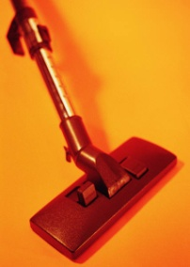
- Items must be appropriate for task – many instances of damage or injury have resulted from trying to complete a cleaning job without the right tools
- Make sure all necessary attachments for vacuum cleaners, polishers and other equipment are taken with you before leaving the cleaning store to enable you to complete the intended task. This saves time and effort
- All electrically-powered and battery-powered items must be used strictly in accordance with manufacturer’s instructions. If you don’t know how to use an item either read the instructions or ask an experienced staff member to show you what to do
- A standard check with any piece of electrical equipment is to ensure the electrical cord is safe to use – not frayed or broken and with no wires exposed
- Make sure any battery-operated equipment is adequately charged before using it. Low battery power can adversely affect cleaning performance and causes time loss when the job has to be interrupted to remedy the situation.

Preparing work area
Minimise customer inconvenience
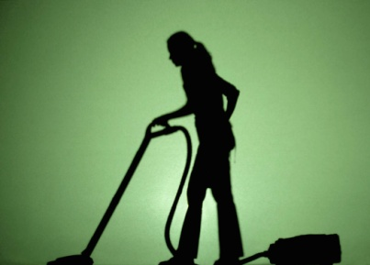
Even though cleaning is a very important task, it must be undertaken with some sensitivity.
Just because it is important does not give us permission or the right to do it when and as we please.
Common sense must be used when scheduling and performing cleaning tasks. You cannot simply go ahead regardless, if cleaning would create an unsafe situation for patrons or staff, or if it would provide a major inconvenience to people or the operation of the business.
As an example, automatic doors are usually cleaned at night or at another low traffic time to minimise inconvenience to people.
This concept means that we have to be flexible when cleaning. If we have been instructed to clean a certain area, that is traditionally quiet or unused at that time, and we find it busy and full of customers, then the cleaning has to be deferred and rescheduled.
Not only is there a safety issue involved here, but there are also guest comfort and inconvenience factors that demand attention.
Cleaning always requires you to think before acting.
Two things to think about are timing and site availability factors.

Consider:
- Can the job be completed before the area is needed?
- Are there enough staff to handle the job to get it done on time – if relevant?
- Have you got the right chemicals and enough of them to allow the job to be started and finished without interruption – the more interruptions there are to the cleaning process, the higher the chance that we will inconvenience someone?
- All the supervisors, clients and users are happy for the intended work to proceed?
Never just assume you can go ahead even when given a job card. Always check first.
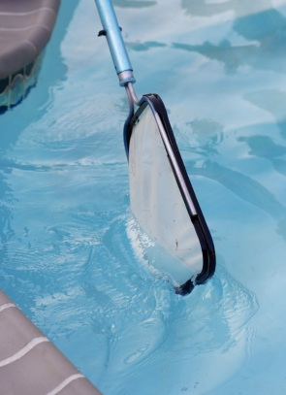
Cleaning activities are normally timed to occur, for the most part, when public activity is at its minimum.
There will always, however, be times when cleaning must be done while people are in the area. This may be a regular pattern of events such as the on-going cleaning of public areas such as reception lobbies, swimming pool areas or caused by particular one-off circumstances such as functions, special events.
In essence, most other activities will take precedence over cleaning. While one hopes for mutual co-operation and understanding in the workplace between staff, this usually translates into cleaners needing to stop what they are doing so that other work can go ahead.
Commonly this means that you may be unable to start or complete a certain activity such as sweeping or mopping a floor, and that you will have to move on and clean the toilets and car park and then come back to do the floor.
When cleaning you must always strive to keep the interruption and disruption caused to anyone to an absolute minimum.
Cleaning duties can disrupt customers:
- As a result of noise caused during the cleaning activities
- By providing a physical obstruction to them when they are moving about
- Through unwanted interruption to their activities in the room where you are cleaning.
Cleaning duties can disrupt the work of other staff and the operation of the business:
- By not being completed by the scheduled time – meaning that a department isn’t ready when expected leaving staff standing around waiting for you to finish
- When cleaning staff and cleaning equipment are present in areas when other staff are trying, or preparing to, deliver service to patrons

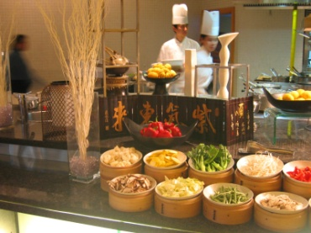
- By not accommodating unforeseen operational issues into the sequence in which areas are to be cleaned, or into the extent of cleaning to be provided. For example:
- A dining room due to be cleaned at 9:30PM is still full of in-house guests who are dining there, spending well and enjoying themselves. Go ahead and do other cleaning duties now and return at 11:00PM to do the dining room
- A lobby area due for a full clean is found to be teeming with 300 check-in guests who have just arrived with their luggage on several buses. Just do a spot clean, empty the bins and tidy things up. Leave the vacuum cleaning and scheduled cleaning of the drapes until tomorrow.
You can further minimise interruption or disruption by:
- Observing ‘Do Not Disturb’ signs on guest rooms if you are cleaning them
- Keeping noise to a minimum when moving around any accommodation area, function room or area being used for a meeting or conference
- Conversing quietly with other staff and guests. Only converse with patrons when they initiate the discussion
- Keeping trolleys and cleaning equipment out of high traffic areas.
Identify hazards
Before an area can be cleaned it must be assessed and prepared and cleared of any items and hazards.
This must be regarded as standard operating procedure when undertaking any cleaning task
A hazard can be defined as a source of danger.
Assessing the cleaning task to be done is the first step in any cleaning job.
Assessing the job means taking a quick look at the area to be cleaned and determining things like:
- Can I do the job now? Should I do the job now? Or does it need to be re-scheduled for one or more reasons?
- Have I got all the equipment and all the chemicals and cleaning agents I need to do this job, or do I need to go and get something else now that I have seen what is involved? There is no point starting a job and having to leave it half-way through while you go and fetch other items that are needed
- Do I need extra staff, or can I do it on my own or with the staff I already have? Where time is critical there can be a need to get extra staff to assist
- What special challenges does this job present, if any? Does it have to be done by a specific time? Are there special cleaning standards etc that need to be applied to this job? Are there any cost limitations in terms of material or labour?
- What hazards are present in relation to this job? Are there special dangers inherent in this job that make it different than normal or which present special threats?

Hazards
In terms of cleaning duties and considering the dangers present in the cleaning work site, hazards may include, but are not limited to:
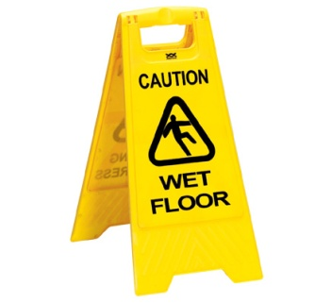
- Spillages of food and liquids or all types
- Breakages of packages, individual items, glass containers
- Wet or slippery surfaces – which may include from natural elements
- Broken or damaged furniture
- Fumes
- Blood, human waste, needles/syringes, and surgical dressings

- Used condoms
- Sharp objects including syringes, knives, blades and skewers
- Broken glass – from windows, glassware, mirrors
- Fat and oil
- Heated/hot utensils and surfaces
- Sharp food scraps such as bones and crustacean shells.
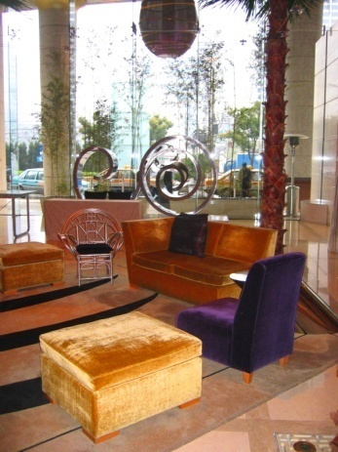
Note that the time of day and the physical location of the area to be cleaned can also form part of the threat/hazard matrix that may need to be assessed.
For example, entering a remote part of the property on your own at 3:00AM may be deemed dangerous, but doing so at 1:30PM may be quite alright. This highlights that many cleaning jobs are subject to unusual hours when there are fewer members of the public around and there is a higher incidence of illegal activity.
All areas must be cleared of hazards before cleaning can commence.

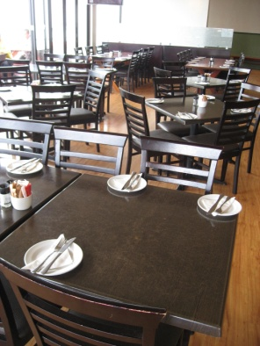
Some basic procedures
When preparing to clean an area the following should be applied where necessary:
- Never take chances if you think you may harm or injure yourself, another person or property. Never start a cleaning job if you are concerned for your personal safety. You should also immediately stop any cleaning job where you believe a danger exists
- Make sure you have all the necessary equipment and materials before you start to do the job properly and completely. Some jobs such as stripping and re-sealing a floor can’t be stopped and started
- Move items that pose a hazard, that might get damaged during the cleaning process or get in the way of the cleaning process and slow the job down. Items that may need to be moved or removed may include guest property as well as enterprise assets
- Where items have to be moved to allow the cleaning to be done, the items that have to be moved must be removed to a place that doesn’t cause them to become hazards such as tripping hazards, obstructions in their own right somewhere else
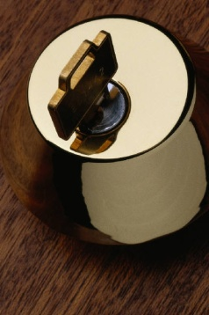
- Ensure the security of any items that have been moved. Keep them in-sight, keep them behind locked doors, put them out of temptation’s way
- Replace items that have been moved when the job has been completed
- Lock doors where necessary to maintain security – if you had to unlock a door at night to enter a bar, a room then you should lock that door again once you are inside. This is not so much to lock yourself in, but to lock potential offenders, thieves, etc. out
- Turn off alarms when entering an alarmed area.
Preparatory cleaning tasks
Most cleaning jobs can be seen as comprising four separate parts:
- Preparing the area
- Setting-up equipment and materials
- Doing the job
- Cleaning up/finishing up after the job.
The cleaning-related tasks that can be seen to be part of the preparatory process prior to ‘actual’ cleaning can include:
- Moving the cleaning equipment and materials into a position that will enable them to be readily used – close to the job but not interfering with the work that needs to be done
- Walking over the area and picking up any loose rubbish – papers, discarded boxes, large items, by hand and putting them into a rubbish receptacle

- Sweeping the area – to remove dust. In some cases ‘sweeping’ may be the entire cleaning job that needs to be done but in many cases, sweeping can be seen as a preparatory task for others jobs such as wet mopping, stripping etc
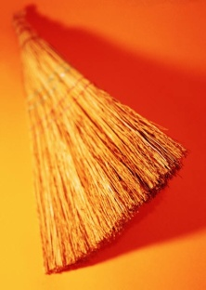
- Setting up or assembling any equipment that needs to be put together
- Mixing any chemicals or preparing chemicals and cleaning agents that will be needed
- Deciding where to start the job, the physical direction the work will take and where the job will conclude. This is often vital with cleaning tasks because you often don’t want to walk over surfaces that have just been mopped, re-sealed etc and you have to make sure you don’t trap yourself into a corner. Working from the furthest point back to the entry door is a usual work direction.
Barricade the work area or place safety warning signs
Extreme care must be exercised when cleaning any public area.
There is always the potential for a guest or staff member, to be injured as a result of the cleaning: this is not just a bad public relations outcome, but it can mean a lengthy and expensive court case that also causes negative relations with the wider community.
One way of limiting the possibility of guest or other injury is to barricade the work area or put in place appropriate warning signs every time cleaning is undertaken. This applies equally to front-of-house and back-of-house areas.
Signage and barriers serve three purposes:
- They warn people of danger – reducing the risk of injury due to slipping
- They help keep people away from the work area – which allows us to work unimpeded and keeps their feet off surfaces that need to dry
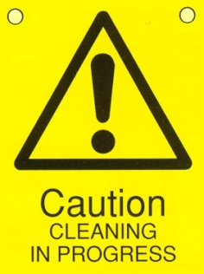
- They are evidence that the establishment has discharged its duty of care obligation to others.
Failure to display these warning signs, etc provide guests and staff with a ready-made legal case should they fall, trip or otherwise become injured as a result of the cleaning being carried out.
The courts have left us in absolutely no doubt that we are wholly and solely responsible for and worker safety. We have a duty of care to maintain a workplace that does not pose a risk to people, and where we breach that duty and injury results, we can expect severe penalties.
The need to barricade or use appropriate signs for every cleaning job cannot be over-emphasised. All too often, cleaning staff become complacent and fail to barricade the area adequately, and this always seems to be the time when an injury occurs.
When barricading an area, common sense must be applied. If there are too many people in the area, then, as already mentioned, cleaning has to be deferred and done later.
Barricades and signage must be put in position before any cleaning begins.
The following points should be followed with reference to barricades and safety signs:
- ‘Slippery When Wet’ signs must be used when mopping or working with a slippery surface – there must be sufficient of these signs to provide suitable and adequate warning to anyone who may enter the cleaning area from any direction. They must be sufficient to be ‘readily visible’
- During cleaning, ‘Cleaning in Progress’ signs should be posted as a warning to patrons and staff in the same way that Slippery When Wet signs are posted
- Physical barriers (fluoro-tape) and physical restraints (purpose-built safety barriers) may be used to restrict access to a site
- Locked doors are another practical way of denying access to areas and rooms
- Your workplace may have other signage that they require you to erect when cleaning is being done – often the signs that are available will depend on the company from whom they were bought.
To find out what applies:
- Ask your supervisor
- Read relevant Work Instructions, Job Safety Analyses, or Standard Operating Procedures (SOPs).

Use equipment correctly and safely
All cleaning equipment should be used correctly, and only used for the purpose for which it was intended.
Use of equipment must be in accordance with the manufacturer’s instructions at all times: this means you must access the instructions for each item, and take time to read the manual.
Where you are unsure about the use and operation of equipment, contact your supervisor or the equipment supplier for advice.
There are some key points to remember when using equipment of any type or style.
They are as follows:
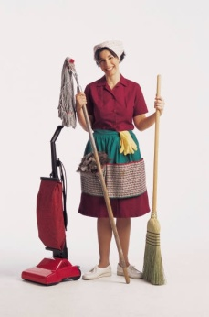
- Don’t use an ordinary vacuum cleaner to soak or clear away liquid – you must use one that is classified as a wet vacuum cleaner
- As soon as a fault has been identified it must be reported – not only is this a genuine safety concern, but it may also impact on the effectiveness of the item and render it less than totally efficient
- The right equipment should only be used on the surface it was designed to clean, in accordance with the manufacturer’s instructions – avoid trying to ‘make do’ with what you’ve got: if you need a special item to clean a certain item/area then you should obtain what is needed and not ‘force’ what you have got to do the job
- Follow manufacturer’s instructions.
Where you are unsure about how to use any item, ask your supervisor.
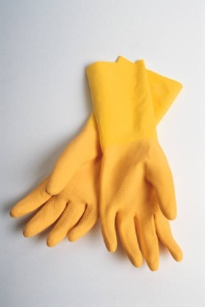
Employer responsibilities
Employer OHS responsibilities may include:
- Providing safety training and clear safety rules
- Encouraging a Workplace OHS Committee – the aim of the committee is to identify areas in the workplace where changes should be made so as to create a safer working environment: this may include upgrading equipment, equipment training and safety matters
- Maintaining an injury register - so that accidents are logged for insurance and monitoring purposes
- Adhering to all workplace agreements that include reference to OHS matters, issues, protection, training, qualified personnel etc
- Providing information and written instructions in all appropriate languages – where there are workers from non-English speaking backgrounds it is not acceptable to only provide advice, information, direction etc in the English language. This information must also be provided in a language that can be understood by the workers
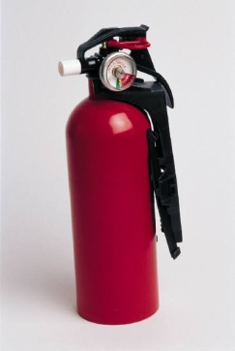
- Providing all necessary PPE to perform the required work
- Maintaining a safe workplace for their employees and monitoring health and safety issues – including checking and servicing of equipment and machinery which must be maintained and must conform to relevant safety standards
- First aid must be provided to all employees when and where necessary - this covers employees when they are coming to and from work, provided the accident is not self-inflicted or of a malicious or wilful nature.
Employee responsibilities
OHS workplace obligations imposed on staff include:
- Working in a way that ensures personal safety, and the safety of others including colleagues and customers – this is a legal responsibility to look after your personal welfare and includes the requirement to avoid engaging in activities that can compromise or jeopardise the safety of others including playing around in the workplace
- Using safety equipment strictly in accordance with the manufacturer’s instructions – which means avoiding taking short-cuts and avoiding the belief that you have found a better way to do things
- Using all personal protective equipment and clothing when and where required and in a correct manner – this means using items such as goggles, masks, gloves, guards every time they are required, no exceptions
- Following all occupational safety and health regulations in-line with establishment requirements. A fundamental for doing this is to know what these requirements are: if you don’t know or aren’t told. Ask!

- Reporting accidents, injuries or illness to the appropriate person – so that help can be provided where needed or appropriate action taken to prevent an accident from occurring where a hazard has been reported, prevent a repeat event occurring, minimise damage, loss or injury
- Reporting any equipment in need of repair
- Adhering to all workers’ compensation laws and regulations – which may include:
- Complying with reporting requirements in relation to the accident
- Participating in Return To Work programs so that rehabilitation can take place and a speedy return to the workforce can occur
- Not interfering or getting in the way of a person who is trying to assist another in need.

Safe manual handling practices
Manual handling activities are the main cause of injuries in the workplace – they include:
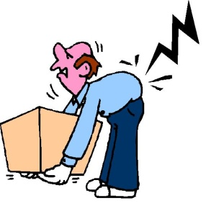
- Lifting – of equipment, chemical containers, cartons etc
- Carrying – items from storage areas to cleaning trolleys, moving items to work areas
- Pulling – boxes and cartons forward in storage areas, moving cleaning equipment
- Pushing –trolleys and cleaning equipment.
Key points to remember when engaged in manual handling activities are:
- Get a risk assessment done on any job you believe poses a threat or hazard – involve your Occupational Safety and Health representatives and Committee (where applicable)
- Push cleaning trolleys and cleaning equipment; don’t pull it. It is important for you to see where you are going
- Always stock items in their designated place on the trolley - it is best to position heavy items on the bottom to prevent the trolley from overturning. If you are not sure where things go – Ask!
- Never lift anything on your own that weighs over 16 kg – this is a recommendation from OHS authorities. There is no maximum weight restriction as the current approach to workplace safety is to assess every lifting need on an individual basis and use the most appropriate technique depending on the type of load, how far it has to be moved, the size of the load etc. Chemicals can be delivered in drums of 25 litres and 20 kg
- Be prepared to ask for help when needed – this may be a request for help such as to do a ‘team lift’ or a request for information. You must also be prepared to provide help when required.

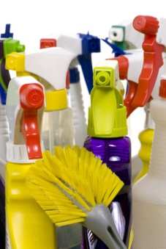
Cleaning agents and chemicals
All cleaning agents and chemicals are designed to clean specific surfaces.
It is most important that the correct cleaning agent or chemical is used on the correct surface.
Using the wrong cleaning agent or chemical on the wrong surface can destroy the item, requiring it to be discarded and replaced.
This highlights the need for you to actually select cleaning agents and chemicals as opposed to just using them.
Safe handling of chemicals
Whenever you are required to deal with chemicals employers are under a legal obligation to provide you with:
- Appropriate and sufficient training and information
- Adequate monitoring and supervision
- Necessary safety equipment and protective clothing.
Material Safety Data Sheets
Employers are also required to ensure that all chemicals used in the workplace are accompanied by a Material Safety Data Sheet (MSDS).
These Material Safety Data Sheets must be kept near the chemicals, and cover issues
such as:
- Product classification
- Storage requirements
- Transportation regulations
- Safe handling procedures
- First aid.
Any chemical users must know where these sheets are and abide by any specific directions or cautions.
Suppliers of chemicals are obliged by law to provide you with MSDS for any chemicals you purchase from them.

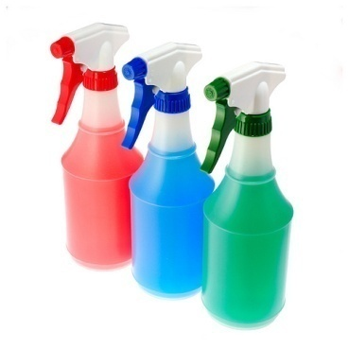
General rules for dealing with chemicals
- Always follow the manufacturer’s instructions – this is the Golden Rule when handling, using or otherwise dealing with chemicals or cleaning agents
- Never mix chemicals together - doing this can cause them to be ineffective, can cause them to give off toxic fumes, and can cause them to explode!
- Read the label
- Contact the supplier or your supervisor if unsure about any aspect of using or dealing with any chemical
- Never store chemicals with food – it is illegal to do so
- Avoid contact between bare skin, eyes, mouth etc and any chemical – this applies to direct contact, as well as indirect contact
- Follow the specific advice on the relevant MSDS if you swallow a chemical or get it in your eyes or on your skin
- Work in ventilated conditions when using chemicals
- Avoid contact between food items and chemicals
- Always wear the personal protective clothing and equipment provided by your employer when dealing with chemicals
- Don’t handle chemicals until you have had appropriate training either from a supervisor, an experienced staff member or a representative from the company that supplies the chemicals
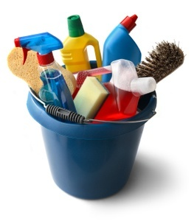
- All chemicals should be stored in a designated ‘Chemicals Store’ fitted with appropriate HAZCHEM signs
- Only use the designated items to measure chemicals to be used – never use jugs or containers that could then be inadvertently used elsewhere in the property for food preparation or service purposes
- Treat the handling of chemicals with the seriousness it deserves – focus on the chemical handling task at hand. Don’t allow yourself to get distracted. No messing about while working with chemicals
- Make sure an approved ‘Chemicals Register’ is kept on the premises.

The following table (from Work Safe Victoria) indicate the sorts of problems that chemicals can cause to people in our industry
Hazard type | Who? | Effect on the human body
Cleaning – using detergents & cleaning agents in washing, disinfecting, general & specific-purpose cleaning; swimming pool cleaning & maintenance; beer line cleaning; degreasing tasks; oven & drain cleaning | Cleaners  Grounds staff  Housekeeping staff  Cellar persons  Bar staff  Kitchen hands  Maintenance staff  Outside contractors | Headaches & dizziness  Sleepiness  Itchiness & rashes  Nausea & vomiting  Burning to skin & eyes  Difficulty breathing  Coughing & watering eyes  Unconsciousness  Cancer & birth defects  Damage to internal organs  Respiratory tract infection
Insecticides & pesticides – using to control pests & rodents; to eliminate or control pests on flora | Grounds staff  Housekeeping staff  Cleaners  Maintenance staff  Outside contractors | Headaches & dizziness  Sleepiness  Itchiness & rashes  Nausea & vomiting  Burning to skin & eyes  Difficulty breathing  Coughing & watering eyes  Unconsciousness  Cancer & birth defects  Damage to internal organs  Respiratory tract infection
(Source: WorkSafe Victoria)

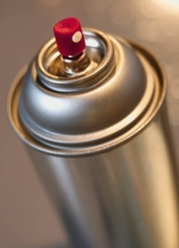
Selecting and preparing chemicals for use
Chemicals may be delivered in:
- Liquid form – most detergents, cleaners, sanitisers, and disinfectants
- Dry/powder form – some detergents come in this dry/powder form
- Aerosol form – for pesticides and deodorisers
- Paste form – polishes.
The trend is for the one property to buy all their chemicals and cleaning agents from the one chemical supplier. This means you may have several detergents from this company, all of which have been designed to do different jobs.
How do you find out which one to use for a particular job?
- Talk to your supervisor or a rep from the chemical company
- Check the FSP regarding chemicals in food areas
- Read the label on the drums/containers
- Check out any wall charts provided by the supplier.
Dilute properly
Read the label and use the chemical correctly.
Some chemicals will be used undiluted at all times. Some will be used neat in certain applications and diluted in others. The level of dilution can vary depending on the type of application.
Always measure chemicals, never guess at how much you are using.
Always follow the manufacturer’s instructions.
Follow relevant work procedures
Where the employer has specific, written directions that relate to selection, preparation and application of chemicals these must be followed.
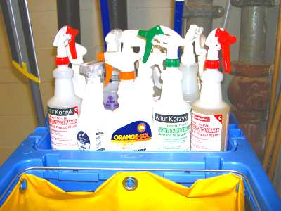
You should be made aware of what these are during induction and other on-the-job training.
They can take the form of:
- Job Instructions
- Checklists
- Job Safety Analysis
- Work Instructions.

Types of cleaning agents and chemicals
There are numerous industrial chemical companies in the marketplace, and a wide variety of cleaning products available.
The brand or type used in one establishment can vary greatly to the brand or type used
in another.
Cleaning companies will work with you to identify and understand the cleaning jobs you need to complete and recommend appropriate products with the necessary active ingredients.
Most companies will provide you with samples to allow you to test the products before you buy them.
Water
Most cleaning products come in a concentrated form meaning, they should be diluted with water before being used.
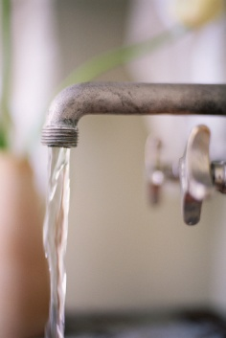
It is vital that you determine whether the cleaning agent or chemical you propose to use needs to be diluted or whether it can be used neat: damage can be caused by using neat product when it should have been diluted.
Water is also important in the cleaning process because it is also used to:
- Loosen and dissolve dirt and grime from surfaces
- Rinse surfaces and cleaning equipment.
Remember that clean water should be used at all times and dirty water should be disposed of appropriately – which means down a gully trap or a designated sink for emptying buckets.
Soap

Generally, soap is made from animal fats and caustic soda.
Soap can be an effective cleaning agent for some surfaces, but it can leave an unacceptable and unattractive residue.
If not dried quickly, this residue will dry and create the need for the entire surface to be cleaned again. This residue needs to be removed with a detergent-based product.
In general terms, soap is not used for cleaning equipment/surfaces.

Polishes
Polish can come as a paste, liquid or cream form.
Polish protects surfaces and forms a barrier against liquids that may harm the surface.
Spirit-based polishes are generally used for metal surfaces as well as windows and mirrors.
Oil-based polishes are generally used for leather, wood, synthetic flooring, linoleum and tiles.
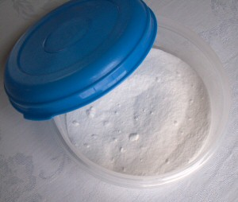
Remember that surfaces can be slippery after they have been polished, so polish should be used with this in mind.
Abrasives
Abrasive cleaning agents are available in powder, cream or paste forms.
They are used for scouring and cleaning ceramic or enamel surfaces.
An example of such a surface is the toilet bowl or the shower basin: abrasive cleaners must not be used on surfaces that scratch easily.
Abrasives can be hard to rinse away, so it is important to wipe and rinse as soon as possible after application: if they are left to dry, abrasives can be much harder to rinse and clean away, and may leave behind a harmful residue.
Detergents
Detergents are chemical-based and can vary in strength; therefore it is important to follow the correct dilution instructions when using this type of cleaning agent.
Detergents have different pH scales and it is the pH level of the detergent that informs the user of the type of surface it is best used on.
Acidic detergents (graded as having a pH of 1 to 6) should be used for cleaning ceramic surfaces.
A pH of 7 is a neutral pH level and these types of detergents are useful for general cleaning.
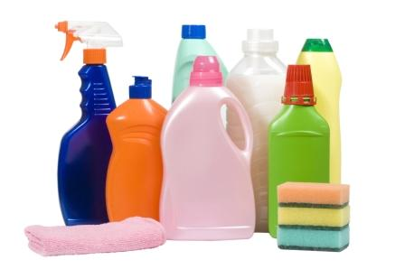
Alkaline detergents (graded as having a pH of 8 to 14) should be used only for specialist tasks, as they can be corrosive and have the ability to damage a surface.
High alkaline detergents should be used only as directed and only on surfaces they were designed to clean. The surface they are used to clean should also be rinsed thoroughly to remove any harmful residue.
Remember that high alkaline detergents can be harmful to the skin. They should be treated with care and spillage should be avoided at all times. Protective clothing should be worn when using high alkaline detergents.

Specialised Cleaning Agents
Cleaning chemicals have been developed to address specific cleaning tasks. Check what is available in your workplace or cleaning store and use them where appropriate.
These ‘specialty’ products have been developed for:
- A range of floor and carpet cleaning needs – specific for different surface types (tile, lino, carpet, wood, etc) and specific stains, dirt of types of damage. These include stripping and re-sealing products for hard floor surfaces
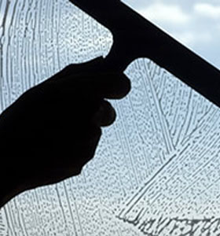
- Windows and glass
- Stainless steel
- Leather
- Aluminium
- Toilets
- Various laundry uses
- Cleaning specific equipment and areas – such as rubbish bins, smokehouses, vehicles, furniture polishes.
Solvents
Solvent-based detergents will dissolve heavy grease and oil.
It is most important to realise that not all surfaces can be cleaned with solvent detergents.
For example, it would not be appropriate to remove oil that has been spilt onto a lounge suite with a solvent detergent. However a metal surface could remain unharmed if cleaned with a solvent detergent.
Again, refer to the manufacturer’s instructions when using such a cleaning product.
Remember that solvent-based detergents may be harmful to the skin. They should be treated with care and spillage should be avoided at all times.
Surfaces that have been cleaned with solvents must be rinsed thoroughly to remove any harmful residue.
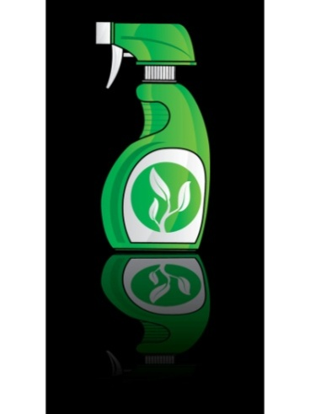
Disinfectants
Disinfectants are cleaning agents that destroy disease-carrying micro-organisms.
Disinfectants should be diluted according to manufacturer’s instructions: if it is diluted too much the disinfectant will become ineffective.
Disinfectants have a strong scent and so are not suitable for use in a kitchen or any food area.
Disinfectants should be used only in the toilet, bathroom and change areas.

Deodorisers
Deodorisers are used to mask or eliminate unpleasant smells.
They are commonly in aerosol form and should be sprayed sparingly to achieve their aim but not dominate or over-power.
Urinal blocks are also used to mask smells in gents’ toilets. When using them follow the recommended dosage rate. Don’t simply throw handfuls of them into the urinal! They are expensive and on their own they don’t provide any cleaning function.
The moral being, you still need to clean the urinal even where these blocks are used.
Websites for chemical suppliers
It is best to start off by looking at the company that supplies the chemicals to your workplace to gain more information about them and their products and services.
Check out:
- http://www.johnsondiversey.com/
- http://www.peerless.com.au/
- http://www.jasol.com.au/.
Environmental issues

As businesses seek to reduce their pollution levels, carbon footprints and overall energy usage, there has been growing concern about the use of chemicals.
The emergence of a ‘green chemicals’ movement has occurred but it appears very much in its infancy at the time of writing with many alternative options to chemicals being used primarily in homes rather than businesses.
Businesses that are looking to live up to a claimed ‘green and caring’ image will currently look to the following in relation to environmental concerns regarding chemicals:
- Monitoring the green chemical movement
- Advising chemical suppliers they are seeking for environmentally-friendly chemicals – and will buy them if they are developed
- Training staff in the correct usage of chemicals – so that chemical usage is minimised consistent with achieving the desired workplace outcomes and standard: a primary aim here is training staff to use only the right amount of chemicals, measuring quantities rather than guessing at them, mixing only the amounts needed to complete a job rather than mixing ‘too much’ and wasting it
- Securing the chemical store to prevent unauthorised use of the chemicals
- Disposing of chemicals in environmentally sensitive ways that align with legal requirements.

Types of surfaces to be cleaned
There are a number of different surfaces that need to be cleaned in public areas.
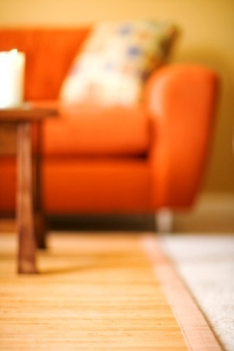
Common surfaces to be cleaned within a hospitality organisation include, but not limited to:
- Leather upholstery – chairs and couches
- Fabric upholstery – curtains, chairs, couches
- Glass surfaces – mirrors, windows and glass tables
- Ceilings, walls, surfaces and fittings
- Wet areas – floors.
The approach and methods used to clean each of these surfaces will be discussed in detail in each of the following sections.

Disposal of garbage and used chemicals
Once garbage has been collected from the room, public areas and kitchen, it must be transported safely to the appropriate garbage location, usually a dump master.
Near the dump master there may be a number of recycling stations– paper, plastics, cans and as much garbage as possible should be recycled.
Protective clothing should always be worn when handling or disposing of garbage.
Chemicals are different to garbage and should be treated as such.
Disposal of garbage
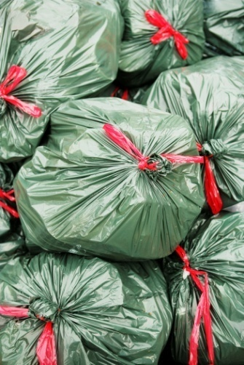
Garbage must be disposed of regularly – it must never be allowed to accumulate inside the premises. A minimum requirement is to remove all garbage on a daily basis.
In addition:
- Comply with any recycling protocols the business has
- Make sure all rubbish goes into the bins and is not left lying around next to them
- Close lids to bins after using them. There may be a need to lock them to prevent unauthorised use
- Use the appropriate bin/disposal system for the appropriate type of rubbish. Liquid waste will be separated from solid waste
- Wash hands after handling rubbish.

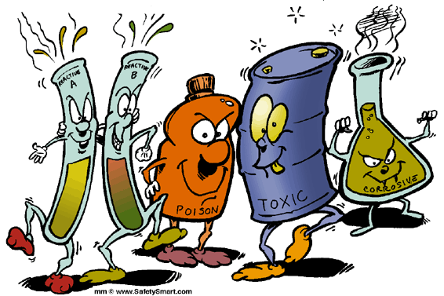
Disposal of chemicals
When cleaning, handling and disposing of chemicals, the following points should be adhered to:
- Chemicals should never come in direct contact with the skin – always wear PPE
- When spilt, chemicals should be initially soaked up with sand, earth or some kind of designated absorbent material.
Left-over chemicals in undiluted form must never be disposed of down a sink or a gully trap.
State and local laws address the environmentally friendly and safe disposal of chemicals by requiring them to be:
- Taken to designated collection sites
- Collected by specially licensed collection businesses.
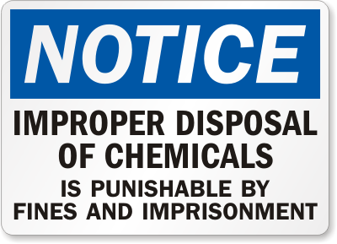
Chemicals should only be poured down drains that are fitted to chemical traps – never assume a drain leads to a chemical trap.
Where you are unsure about the requirements for disposal of chemicals, contact your local council for relevant local requirements. They will give you advice as to how to comply with current relevant legislation.
Chemicals must not be poured down stormwater drains in order to prevent pollution of the environment and avoid the risk of fines and adverse media attention.

Cleaning and maintaining PPE
All equipment and PPE must be cleaned before being stored.
This is to enable it to be ready for immediate use and to reduce the chance of being affected by chemicals etc.
Note that personal hand washing is a significant part of maintaining and cleaning any PPE. Protective gloves should be worn when cleaning and maintaining PPE.
Manufacturer’s instructions must be followed when cleaning or maintaining any PPE.
There is relatively little that individuals can do in relation to repairing PPE. It is usually the case of returning items to suppliers for service, or throwing them out and buying a new one.

Safety-checking equipment and PPE
All PPE must be safety-checked prior to storage.
Appropriate requests for maintenance and replacement must be made at this stage if problems are identified.
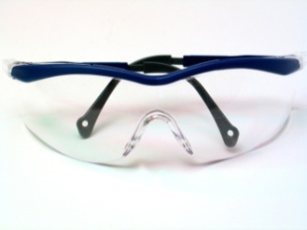
Standard PPE checks include:
- Checking for rips and tears to gloves and aprons
- Checking for holes and leaks in safety shoes
- Verifying the integrity of safety glasses
- Replacing the filters in respirators.

Clean equipment after use
It is important for all equipment to be cleaned after every use.
This will ensure that dirt and grime from a previous cleaning task is not transferred on to another surface.
Manufacturer’s instructions coupled with house policies will dictate what needs to be done in individual circumstances.
Equipment that requires cleaning and the possible techniques that can be used include the following.
Check what applies where you work and where these differ to what is provided, adhere to house requirements. If in doubt, ask your supervisor.
Mops
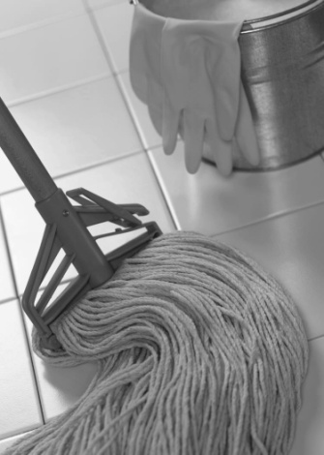
Cleaning of the three main types of mops:
• Dusting mops – after use, shake thoroughly in appropriate location (outside) then wash in hot soapy water and hang out to air dry
• Polishing mops – on a regular basis, remove fluff and rinse mop in turpentine, which will remove the polish – after the mop has been squeeze-dried, re-coat with polish
• Washing mops – on a regular basis mops should be washed in hot soapy water, rinsed thoroughly, squeeze-dried and then hung up to air dry. Sanitising is recommended and should be mandatory where the mop is used in food areas.
Dusters
Cleaning of dusters involves their being shaken clean regularly in the appropriate location (outside), and then washed in accordance with the manufacturer’s instructions.

Brooms and brushes
Cleaning of brooms and brushes involves their being shaken clean, washed in hot soapy water, and then left to air dry.
Cloths and sponges
These should be cleaned on a regular basis using hot soapy water, and left to air dry.
Buckets
They should be cleaned out thoroughly after each use with hot soapy water, and left to air dry.
Vacuum cleaners
All vacuum cleaners must be cleaned out at the end of each shift and the bag replaced, if required.
The machine and its attachments must be wiped clean.
The power cord should be wrapped correctly and safely.
All cleaning of vacuum cleaners must be done in accordance with manufacturer’s instructions.
Carpet shampoo machines
Carpet shampoo machine and all attachments must be cleaned out on a regular basis.
The machine must be wiped clean and the power cord should be stored correctly.
All cleaning of carpet shampoo machines must be done in accordance with manufacturer’s instructions.
Floor machines
Floor machines and all their attachments must be cleaned on a regular basis.
All cleaning of floor machines and attachments must be done in accordance with manufacturer’s instructions.

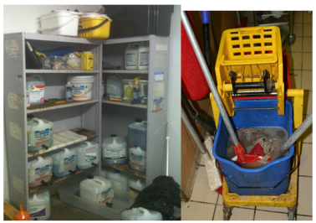
Store equipment in the designated area and in a condition ready for re‑use
All cleaning equipment will have an allocated storage area.
Equipment must be returned to this area after use.
Cleaning equipment cannot be left ‘just anywhere’ after it has been used because:
- It may be stolen
- It may be a hazard in terms of an obstruction or a tripping hazard
- Others may need to use it and they will go to where it should be.
Before equipment can be stored away, it should be checked to ensure it is clean and ready to be re-used.
Never put away equipment that has not been cleaned and checked. If the inspection requires action to be taken, whether to repair or report, do it.
Location for storage
Where a cleaning storeroom exists, items will need to go back there.
A property can have several small storerooms throughout the property. Normally this is one per department or one per floor.
In some cases, certain items (especially larger electrically-powered) may be stored in another location because they are too big to go into the cleaning storeroom area. Adhere to the SOPs where you work.
These storage areas should all be back-of-house locations and fitted with locks to prevent unauthorised access to equipment. Make sure the store is locked when you leave it
It is important that equipment is stored in a clean condition and in the right location for a number of reasons, some of which may include:
Store chemicals according to safety and health requirements
The correct storage of chemicals is of the utmost importance.
Storage areas must be prepared with the appropriate drainage, safety equipment, fire sprinklers and the correct fire fighting equipment.
Access to these stores should be restricted only to staff who have received appropriate OHS training in handling chemicals.
Any undiluted chemicals remaining on your cleaning trolley or in your cleaning bucket must be stored safely at the end of the shift or cleaning task.
House policies will determine whether these chemicals need to be stored in the chemicals store or if they can be returned to the cleaning storeroom. Usually, chemicals in smaller containers (1 litre to 5 litre containers and trigger spray bottles) can remain with the mops, buckets etc or stay on the cleaning trolley or in the cleaning bucket or carry-all.

The following guidelines need to be considered when storing chemicals:
- Keep in a storeroom away from other products – the room should be marked ‘dangerous goods’, have necessary HAZCHEM signage, and restricted access
- A register should be maintained to record items in accordance with legislated requirements
- The store room for chemicals must be well lit and ventilated
- The room should only be used for storing chemicals
- Heavy containers must be stored on lower shelves to avoid the need for lifting, and to minimise the chance of spills
- Keep containers well sealed and labelled
- Have MSDS and first aid directions posted in the area – together with first aid resources to support possible treatment requirements
- Keep away from a naked flame or excessive heat
- Product usage charts should be close to the chemicals for easy and clear reference purposes – including details relating to dilution, items that chemicals can be used on
- Instructions for safe chemical handling must be posted – to provide instruction on decanting chemicals
- Necessary PPE should be present – gloves, aprons, respirators, gauntlets and hoses
- Never store chemicals or cleaning agents in food containers
- Never store chemicals with food
- Do not allow customers to come into contact with chemicals, or entry into the chemicals storage area
- Never mix chemicals together – some may explode
- Ensure measuring devices for chemicals are not used for any other purpose.

Cleaning public areas
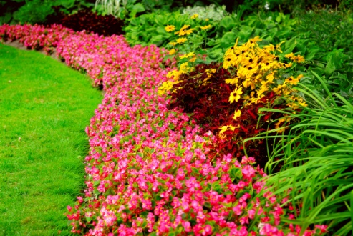
Whilst this manual will focus on cleaning, using different techniques for a variety of public area surfaces, it is important to identify and explain common public areas and steps associated with ensuring these areas remain clean, tidy and ready for use and enjoyment by guests.
Gardens
Many hotels and resorts include garden or natural bush environments. Whilst these areas may not be directly used by guests, they greatly influence the ambiance and natural beauty and tranquillity of the area.
It is essential that all gardens and natural features are maintained in a clean and attractive manner.
In many hotels there may be a dedicated gardening or grounds team, or these functions may come under the responsibility of the public area cleaner.
The gardening responsibilities vary with the seasons but may include:

- Plant, water and trim plants and flowers
- Pull out dead grasses and debris from trees
- Trim and water the grass in order to maintain its mass
- Lay fertilizers and other chemicals to flowers and plants
- Maintain the cleanliness in the garden by sweeping up trash and pulling out dead plants
- Do basic landscaping and designs for the beautification of gardens
- Maintain and develop the gardens to the requirements of the organisation
- Take charge of grass cutting, emptying bins, weed control and leaf raking
- Plant new trees, flowers and various plants
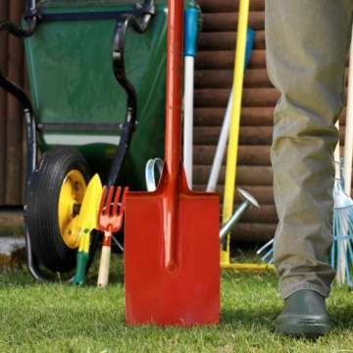
- Drive plant vehicles
- Maintain plant tubs and baskets
- Make sure that all garden equipment is correctly maintained and serviced
- Paint and refinish outdoor patio furniture
- Seed plants and water them at the correct times
- Clear rubbish and litter away from the garden and grounds
- Clean fences, walls and ponds
- Ensure walk ways are clean
- Give advice and guidance to managers on all matters relating to gardening
- Ensure lighting in the garden and around garden furniture and ornaments is in working order and condition

- Ensure a safe working environment for everyone working in the garden
- Undertake the basic servicing and repair of all garden machinery
- Ensure that all water sprinklers are operational.
Swimming Pools
Many hotels and resorts will have an array of water features, with the largest being pools, either for decorative purposes or for the enjoyment of guests.
For resorts, the pool is one of the major draw cards for guests and is the location in which they spend a considerable amount of time.
Therefore it is essential that pools are maintained for the enjoyment of guests.
The following are activities that can be performed by public area cleaners to ensure pools are sparkling clean, inviting, refreshing and ready for use every day.
The key is just staying on top of it.
Routine pool maintenance may also prevent frustration and complaints by customers who are concerned about the appearance or state of pools.
Cleaning pool
The following steps can be followed by public area cleaners to ensure the pool remains clean and inviting for guests:
- Remove leaves and other floating items – pick up junk before it sinks or gets clogged in the plumbing
- At least once a week, clean leaves out of the pool's strainers (the baskets that catch debris)
- Brush your pool walls weekly to remove algae and other culprits - use a soft brush on tile or fiberglass walls and a stiffer brush on the walls of plaster-lined pools. If you need to undertake deeper cleaning, use a nylon scouring pad and a liquid cleaner
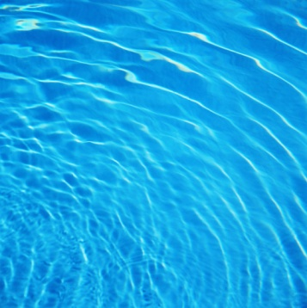
- Vacuum each week to keep the pool water clean. Cover the entire bottom of the pool with your vacuum strokes.
- Keep your pool water sanitized to reduce algae and bacteria. Liquid chlorine is the most common sanitizer, although there are other, newer methods. Use a test kit to tell when you need to add chlorine
- If your pool water is cloudy, check your filter and clean it, if necessary. Different steps are required to clean sand, diatomaceous earth and cartridge filters
- Place a pool cover on at the end of the day if required
- Check pool lighting
- Always keep chemicals stored out of direct sunlight. Keep them in a cool dry place. Do NOT store acid and chlorine right next to each other
- Keep vegetation, animals and chemicals away from and out of the pool.
Cleaning pool area
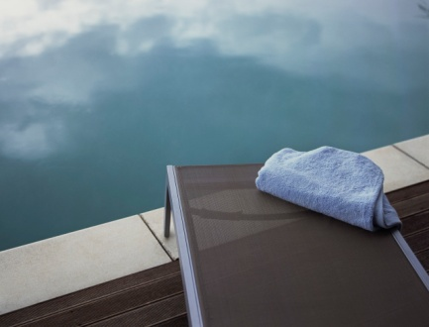
Not only must the pool be inviting, but the pool area itself must also be clean, safe and ready for use.
Activities to ensure a pool area remains operating efficiently include:
- Washing and sweeping tiles around pool and under deck chairs
- Returning pool devices and recreational equipment to their designated areas
- Realigning deck chairs and umbrellas
- Removing used towels and placing new towels on deck chairs or stations, where required
- Removing dirty glasses, plates and napkins
- Cleaning pool side tables and chairs including the realignment of promotions or other table materials.

Car parks and driveways
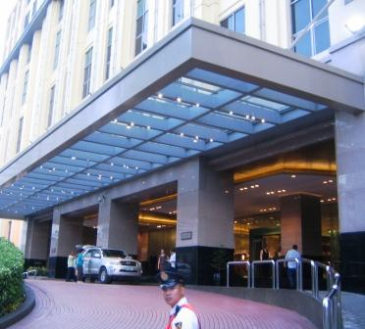
Hotel entrance
The hotel entrance must be clean and tidy as this is not only the first contact point for customers, but is where customers wait whilst their car is being retrieved. In addition, this is the main entrance point for all customers and what passing traffic and walkers see. Therefore it must reflect a well run and professional operation.
The hotel entrance area, incorporating the driveway and outdoor area outside the main doors itself, may be the responsibility of concierge, porters, valet departments or public area cleaners.
Regardless of who is in charge it must be maintained. With this in mind:
- All surfaces must be clean, tidy and void of rubbish
- The waiting area, including seating or queuing area, must be maintained and managed
- Rubbish and smoking areas must be cleaned and clear of rubbish.
Driveways
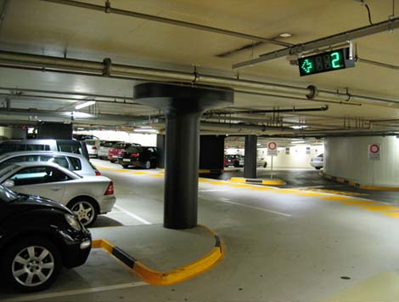
The driveways must be clear of rubbish and cleaned.
Car parks
The car park must be clean and tidy and, like the driveways, clear of rubbish.
Equipment used in this area must be operational and well stocked . These items include:
- Brooms, mops and scrubbers
- High pressure cleaning equipment
- Degreasing agents to remove grease and oil under parked cars
- Fire extinguisher in the event of a fire
- Car cleaning and detailing equipment – including vacuum cleaners, window cleaners, waxing items, polishes, detergents, mops, cloths, disinfectants and rubbish bins to dispose of rubbish from vehicles.
Whilst monitoring of car parks should be a constant exercise, it is important that public area staff undertake a thorough observation of the area. The purpose of this exercise is to:
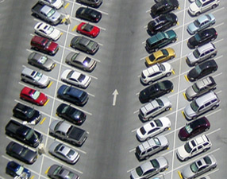
- Ensure that all cars are secure and that no break-ins or damage has occurred
- Identify any items unintentionally left behind, dropped or lost are accounted for and sent to lost property
- Identify general condition of the area including:
- Rubbish and cleanliness
- Broken lights
- Faulty equipment
- Undesirable items such as drug paraphernalia, human waste or broken glass.
Signage
Car parks use a range of signs or ropes to reserve car places or to block areas which may be required for tour coaches etc. These must be located in easy to reach places.
Remove litter from parking garage and driveways
Once a visual inspection has taken place, the next task of all public areas staff is to make sure these areas are:
- Free from obvious rubbish and debris
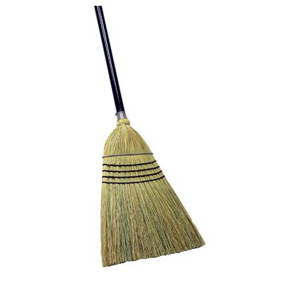
- Clean from dust and dirt.
When cleaning, common tasks include:
- Picking up general rubbish
- Emptying and cleaning rubbish bins
- Cleaning cigarette bins
- Sweeping up dirt and small debris
- High pressure cleaning of walls and ground.
When cleaning is being done, especially in the immediate location of cars or customers, all necessary precautions must be taken including:
- Placing of ‘cleaning in progress’ or ‘caution – wet area’ signs
- Ensuring car windows are closed
- Ensuring water does not get under building doors
- Drying any seats used by customers.
Check lighting
Given hotel operations are 24 hours a day, all lights must be in working condition. Whether the car park is located in a dark underground area or outside, for safety reasons all lights must be operational at night.
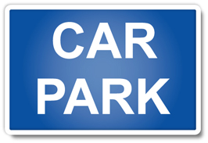
Not only must overhead lights be in working condition, lighting must also be working where the following items are placed:
- Boom gates
- Signs
- Pay stations
- Hotel entrance and lift areas that connect with car parks
- Walking paths and gardens.
In many cases, the location of the lights does not mean public area cleaners have to replace these lights themselves. They may be required to get maintenance or an external contractor (in the event of public lights) involved.
Maintain area appearance
- Watering any fresh flowers or plants
- Spot cleaning where required
- Making sure the external appearance of the property is attractive – by checking the footpath etc.
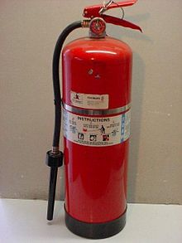
Maintain fire equipment: Fire extinguishers
Fire extinguishers are commonly found in public areas as they are easy access points for both hotel staff and fire fighting experts to gather the necessary equipment to control and eliminate fires.
Quite often fire extinguishers are located in cupboards or other easily accessible and visible locations.
Public area cleaners should check to ensure:
- The fire extinguishers themselves have not been removed
- They have not been tampered with by checking to see if the pin is still in place
- There is no rubbish or other items placed in the cupboard.
If for any reason it appears that the fire extinguishers may not be operationally ready it is important to notify management immediately.
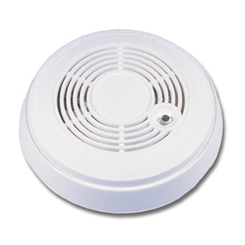
Smoke detectors
All hotels have smoke detectors, not just in kitchens and guest rooms, but in public areas.
These are vital fire detection systems and it is important that they are operational and functioning. There are a number of small actions that a public area cleaner can undertake to ensure they are ready for use including:
- Test smoke detectors once a month
- Press the test button on detectors and check that the device beeps or rings loudly.
- If a smoke detector starts chirping or beeping off and on, it’s time to change the batteries.
Sprinkler heads
When checking smoke detectors it is also a good time to ensure sprinkler heads are also in operational condition and have not been broken in any manner.

Conclusion
In conclusion, this introduction provided detailed information when it comes to general cleaning functions performed by public area cleaners.
Each of the following sections will detail procedures for different and specific types of cleaning.

Element 1:
Apply leather upholstery cleaning techniques

1.1 Assess leather upholstery to be cleaned

Assessing leather
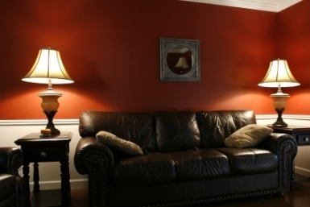
Leather is a popular soft and durable material that is commonly used in furniture. Leather covered furniture is normally used in chairs and booths in restaurants as they look great, but are also easy to clean.
With constant use of this type of furniture, it exposes the material to dust, dirt, and stains, which threatens to ruin the unique finish and beauty of leather products.
However, since leather is used in most F&B outlets, many different tips and techniques to cleaning the material have been identified.
A majority of the leather furniture comes prepared with top-coated protected leather, however this is not always guaranteed.
So before getting started on your cleaning, you always have to double check on the kind of leather you have.
As leather is a durable substance, most cleaning to be performed will be as an on-going preventative maintenance, as opposed to an urgent need for cleaning.
That said, leather covered furniture should be checked whenever arranged at the start of the day and when wiped down and / or stacked at the end of the day.
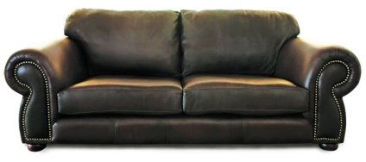
If your leather upholstery needs to be repaired, make sure you repair the damage before proceeding to cleaning, protecting, and conditioning. Though it is rare, you may have to follow a different cleaning method after repairs, so be sure to always do this first.
Always keep leather furniture out of direct sunlight to prevent drying and cracking the leather.

1.2 Select appropriate equipment and chemicals

Equipment
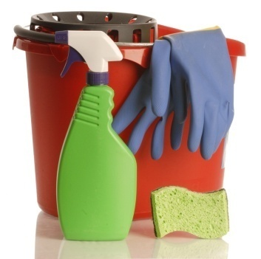
The equipment required to clean leather is fairly simple.
Equipment required
- Vacuum cleaner
- Bucket
- Soft cloth for cleaning
- Soft bristled toothbrushes
- Soft cloth for buffing / polishing.

Cleaning products
Due to the nature of leather, more often than not, strong chemicals are not used.
There is a variety of cleaning products that can be used to clean and maintain leather including:
- Moisturizing soap – for general cleaning
- Rubbing alcohol
- Leather Protection Cream - is a leather conditioner is used to protect leather that repels stains and protects the surface from wear and tear. It feeds, protects and re-instates the smell into old and new leather items
- Products recommended by a manufacturer.

1.3 Prepare work site

Prepare work site
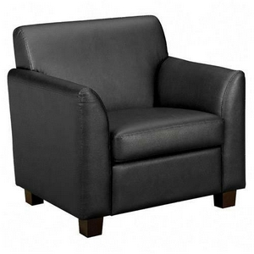
There is no major preparation that needs to be performed before cleaning leather. Most cleaning can take place where the furniture is normally located.
You may want to ensure that any cleaning in conducted at a suitable time between service periods.
Also refer to introduction for detailed steps involved in preparing the worksite.

1.4 Clean upholstery

Immediate cleaning
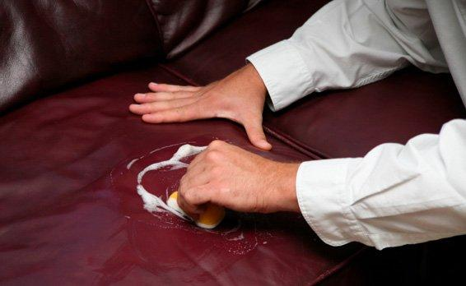
Spills shouldn't be a problem if a leather protector has been applied, but you still have to clean them up right away, just in case the protection is starting to wear off and the moisture does get absorbed by the leather.
For general leather cleaning, use a moisturizing soap. Lather on with a soft cloth, and wash the item to remove dirt and grime. Do not over wet the leather and do not rinse after washing, just buff with a soft cloth. This allows the moisturizing soap to condition the leather. Polish as usual.

Regular cleaning
When cleaning leather, soft materials, such as cloths must be used because leather can scratch easily, affecting its distinct grain or finish.
Cleaning steps include:
- Wiping of leather furniture at the end of a shift, or two or three times a week with a soft rag
- Leather should be dusted or wiped with clean rags two to three times a week. This will help prevent dust and dirt build up, especially in the crevices
- Don't rub down on your furniture too hard as you may accidentally scratch the surface
- Vacuum the furniture once a week using the vacuum's soft brush attachment.

Removing ink
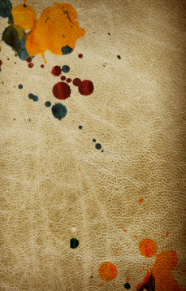
On occasions, ink from pens may spill on leather furniture. The key is to try to remove as soon as possible by:
- Dip the cotton swab into rubbing alcohol
- and rub over the ink stain
- Dry the area with a blow dryer
- If you still see the stain after drying, apply a thick coat of non-gel, non-oily cuticle remover
- Leave this on overnight and wipe off with a damp cloth.

Remove dark stains from light coloured furniture
To remove dark stains from your lightly coloured leather upholstery, follow these steps:
- Mix one part crème of tartar with one part lemon juice to form a paste
- Rub this paste on the stain, leaving in place for 10 minutes; repeat this step
- Remove with a damp sponge or a damp sponge and moisturizing soap.

Annual cleaning
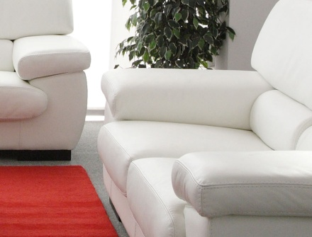
Cleaning leather at least once or twice a year is considered the best method to maintain your pieces.
Follow your cleaning regimen with a leather conditioner. This will make sure that the leather stays supple and doesn't dry out despite the cleaning.
Conditioning leather is very important as this will help prevent dryness and cracks. Try to condition leather after each general cleaning and after repairs have been made.
Apply a leather protector once or twice a year.

1.5 Tidy work site

Considerations
When you have completed the cleaning of leather furniture please ensure that any equipment and materials is not left behind.
Please refer to introduction for detailed information relating to tidying a work site after the completion of work.

1.6 Clean, check and store equipment and chemicals

Steps
Please place any used cloths in a suitable place for cleaning.
Please ensure the vacuum cleaner has been cleaned out of all dirt and other waste products and placed back in a suitable location for further use.
Place all chemicals and other substances used in a storage area out of reach of children.
Please refer to introduction for detailed information relating to cleaning, checking and storing equipment and chemicals.

Work Projects
It is a requirement of this Unit you complete Work Projects as advised by your Trainer. You must submit documentation, suitable evidence or other relevant proof of completion of the project to your Trainer by the agreed date.
1.1 To fulfil the requirements of this Work Project you are asked to research to:
- Steps taken when assess leather upholstery to be cleaned.
1.2 To fulfil the requirements of this Work Project you are asked to research appropriate equipment and chemicals used to clean leather including:
- Types of equipment
- Cleaning products used.
1.3 To fulfil the requirements of this Work Project you are asked to research:
- Steps taken to prepare work site.
1.4 To fulfil the requirements of this Work Project you are asked to research how to clean upholstery including steps taken to:
- Conduct immediate cleaning
- Conduct regular cleaning
- Remove ink
- Remove dark stains from light coloured furniture
- Conduct annual cleaning.
1.5 To fulfil the requirements of this Work Project you are asked to research:
- Steps taken to tidy work site after cleaning has taken place.
1.6 To fulfil the requirements of this Work Project you are asked to research:
- Steps taken to clean, check and store equipment and chemicals.

Summary

Apply leather upholstery cleaning techniques
Assess leather upholstery to be cleaned
Assessing leather.
Select appropriate equipment and chemicals
Equipment
Cleaning products.
Prepare work site
Prepare work site.
Clean upholstery
Immediate cleaning
Regular cleaning
Removing ink
Remove dark stains from light coloured furniture
Annual cleaning.
Tidy work site
Considerations.
Clean , check and store equipment and chemicals
Steps.

Element 2:
Apply fabric upholstery cleaning techniques

2.1 Assess fabric upholstery to be cleaned


Benefits of fabric
Fabric upholstery is used on a large amount of furniture items in hotels as it allows for greater flexibilities of colour, patterns, designs and textures.
It is a great material as it is normally less expensive than leather and in many cases is easy to clean and with removable covers, limits impact on operations, whilst still providing inter-changeable features.
In many hotels fabric is the chosen material for furniture.
Before cleaning fabric upholstery it is important to look at it closely to determine the type of cleaning to be performed.
It is a simple procedure; it can be done by staff. It is involves damage including rips, cuts or deep stains, it may require professional attention.

2.2 Select appropriate equipment and chemicals

Equipment
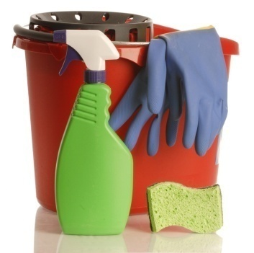
The equipment required to clean fabric is fairly simple.
Equipment required:
- Vacuum cleaner
- Bucket
- Cloths for cleaning and washing away detergent
- Drying machines
- Wet furniture signs.

Cleaning products
Due to the nature of fabric, like leather, more often than not, strong chemicals are not used.
The cleaning materials used to clean fabric are quite simple and standard:
- Liquid or powder fabric detergent or liquid washing detergent
- Cleaning shampoo
- Stain remover
- Warm water
- Products recommended by a manufacturer.

2.3 Prepare work site

Steps to prepare work site
When preparing the work area for cleaning fabric upholstery, the size and location and frequency of use of the furniture will be contributing factors how and when cleaning should take place.
Firstly, it is best to conduct cleaning:
- When it will have little impact on guests
- When it allows for sufficient time to dry before use.
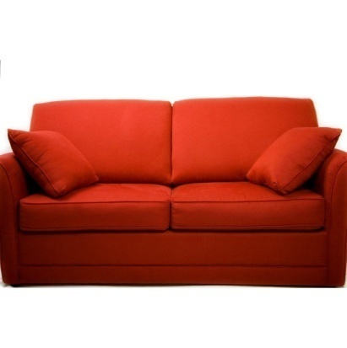
Depending on the size of the furniture, like leather, most of the cleaning will take place where the furniture is actually located.
If this is the case, it is best to:
- Place a ‘wet furniture’ sign in a suitable location to ensure customers don’t sit on the furniture whist it is wet
- Remove any items such as newspapers and magazines
- Vacuum the furniture and cushions.

2.4 Clean upholstery

Introduction
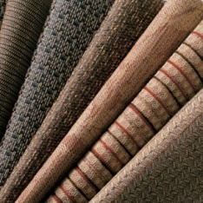
Like with all cleaning procedures, preventative maintenance and up-keeping of upholstered furniture is the most effective way to keep it clean.
This is a simple process of:
- Regular vacuuming of furniture, normally conducted on a weekly basis, to remove any dirt particles, dust and prevent heavy soiling of the fabric.

General cleaning
Steps involved in the general cleaning of fabric include:
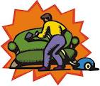
- Remove any loose items from the furniture including cushions
- Loosen dirt with a handheld dusting brush while using a vacuum brush attachment to remove the dust
- Vacuum all surfaces of the furniture: back, sides, arms, skirt and the platform beneath the cushions.
- Vacuum both sides of the loose cushions.
- Remove any cushions
- If the fabric is removable and interchangeable, you may wish to do this to wash in a different area or using a washing machine, if it does not cause damage or shrinkage. It is best to check the manufacturer’s instructions
- Mix laundry or other suitable detergent with warm water. Ensure the detergent has dissolved or has been mixed properly
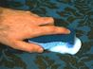
- Select a test area to conduct trial cleaning. This is a location not normally visible when viewing the furniture in its usual location. This could be a small area on the back, bottom or underneath of furniture. Test by dipping a cloth in the water and detergent mix and rubbing a small place on the back of furniture
- Let the trial clean dry. If fading, shrinkage or discoloration occurs, you may wish to have it cleaned by experts
- If no problems have been identified in the trial cleaning process, go to the next step
- Select an area on the furniture, dip cloth and rub water and detergent mix on the fabric
- Dirt or any marks will begin to remove from the fabric
- Use a clean cloth and plain water
- Rinse area with a damp cloth to ensure detergent has been removed from the fabric
- If some stains or dirt remains, you may wish to repeat the cleaning steps until it is suitably clean
- Allow to dry overnight. Some hospitality establishments may have a professional drier or depending on the size of furniture, it may be placed near an open window or outdoors for quicker drying.

Deep cleaning
Deep cleaning your upholstered furniture can be done for a number of reasons:
- Remove deep stains and accumulated dirt
- Help to keep furniture look like as new as possible
- Ensure furniture is as clean as possible, which helps keeps insects and other animals away.
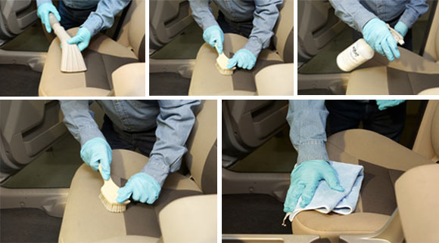
Deep cleaning can be done by people within the housekeeping department or depending on area of specialisation, available resources and time; it may be outsourced to a professional company.
The steps associated with a deep cleaning of fabric upholstery include:
- Remove any blankets, covers or cushions
- Conduct a thorough vacuum ensuring all surfaces of the furniture are cleaned including the sides, arms, both sides of the cushions, the base and underneath section, as well as any corners and creases using an upholstery or crevice vacuum attachment
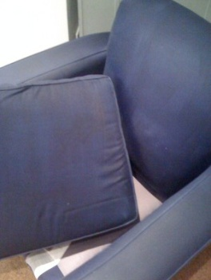
- Replace the cushions back on the furniture
- Check your furniture's label for cleaning instructions before washing
- Prepare a suitable cleaning agent. This may include a specialised shampoo or stain remover
- Similar to regular cleaning, conduct a trial clean
- Ensure no further stains or other foreseeable problems have arisen
- Spot treat any existing stains with a suitable stain remover
- Prepare hot water and add detergent or cleaning shampoo into a large bucket. Ensure that the mixture is well mixed with adequate cleaning bubbles
- Use a rough cloth or brush to clean the upholstery but gently putting part of the cloth into the soapy solution. Do not to soak the fabric
- Use a clean damp cloth to soak up the dirty soap, and rinse with a damp cloth
- Let the furniture dry overnight with an airing fan pointed at the wet furniture to help it dry more quickly.

2.5 Tidy work site

Considerations

Once the cleaning has taken place, whether through the process of a regular or deep cleaning, it is important that the furniture has:
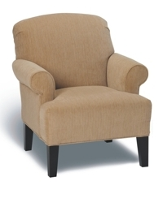
- Time to dry
- Does not attract any dirt or dust during the drying process
- Is not used by customers whilst.
Like with cleaning of leather furniture, you may wish to place a ‘wet furniture’ sign at attract the attention of customers, or take the furniture to a different location, if possible, if the area is still to remain in use by customers.
If the furniture is to remain in its usual location, please ensure:
- All equipment has been removed
- All cushions, blankets and other items to be placed on the furniture is returned
- The surrounding area is clean and dry.
Please refer to introduction for detailed information relating to tidying a work site after the completion of work.

2.6 Clean, check and store equipment and chemicals

Steps
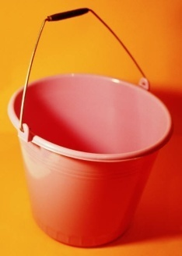
Please place any used cloths in a suitable place for cleaning.
Please ensure the vacuum cleaner and buckets has been cleaned out of all dirt and other waste products and placed back in a suitable location for further use.
Place all chemicals and other substances used in a storage area out of reach of children.
Please refer to introduction for detailed information relating to cleaning, checking and storing equipment and chemicals.
Work Projects
It is a requirement of this Unit you complete Work Projects as advised by your Trainer. You must submit documentation, suitable evidence or other relevant proof of completion of the project to your Trainer by the agreed date.
2.1 To fulfil the requirements of this Work Project you are asked to research:
- Benefits of using fabric to cover furniture
- Steps taken when assess fabric upholstery to be cleaned.
2.2 To fulfil the requirements of this Work Project you are asked to research appropriate equipment and chemicals used to clean fabric including:
- Types of equipment
- Cleaning products used.
2.3 To fulfil the requirements of this Work Project you are asked to research:
- Steps taken to prepare work site.
2.4 To fulfil the requirements of this Work Project you are asked to research how to clean upholstery including steps taken to:
- Conduct general cleaning
- Conduct deep cleaning.
2.5 To fulfil the requirements of this Work Project you are asked to research:
- Steps taken to tidy work site after cleaning has taken place.
2.6 To fulfil the requirements of this Work Project you are asked to research:
- Steps taken to clean, check and store equipment and chemicals.

Summary

Apply fabric upholstery cleaning techniques
Assess fabric upholstery to be cleaned
Benefits of fabric.
Select appropriate equipment and chemicals
Equipment
Cleaning products.
Prepare work site
Steps to prepare work site.
Clean upholstery
General cleaning
Deep cleaning.
Tidy work site
Considerations.
Clean , check and store equipment and chemicals
Steps.

Element 3:
Apply glass surfaces cleaning techniques

3.1 Assess glass areas to be cleaned

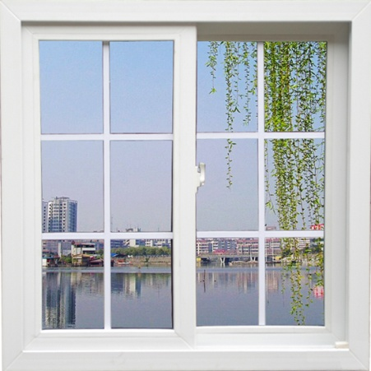
Uses of glass
Glass is used in many hotels as it is very effective in improving the aesthetics of an area and giving the appearance of more space.
Glass is commonly found in:
- Windows
- Mirrors
- Coffee tables
- Showers.

3.2 Select appropriate equipment and chemicals

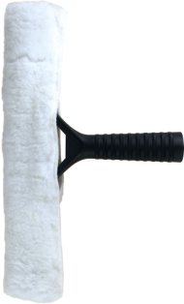
Equipment
Scrubber
The scrubbing wand, sometimes called the T-handle, is one of the window cleaning tools that does the actual scrubbing of the window. The wand is formed in the shape of a T and is made of lightweight durable plastic. A reusable lint-free wand cover sleeve slips over the top and is held in place with snaps or Velcro tabs. The wand is then dipped into a bucket filled with window cleaning product and water.
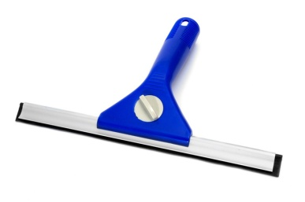
Squeegee
The squeegee is the main tool used to remove the water and cleaning solution from the glass after it has been scrubbed. A squeegee consists of three parts: handle, metal channel, and rubber blade.

Equipment belt or bucket
Having a fully equipped tool belt or bucket is essential to ensure you have everything within easy reach. As you may be on a ladder it is not practical to have to go up and down to retrieve items.
They will hold your squeegee, wiping cloths, scraper, extra blades, and wand bucket, along with other items you may want. Everything is conveniently within reach at hip level.
Having this type of system is the best. It will keep all your tools safe, clean and organized so you can stay focused on the task at hand.
Window Cleaning Buckets
When it comes to choosing a bucket, decide for yourself which one might work best for you. You can choose one that hooks on your belt or one that sits on the floor. The advantage to one that hooks to your belt is that it is convenient when working on ladders.
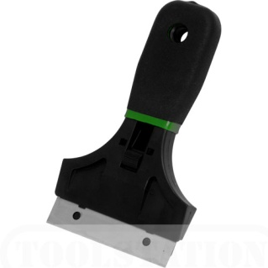
Window Scraper
Tools such as the window scraper are very important to understand. When it comes to removing debris from glass, you want to use a professional grade window scraper. These scrapers are specially designed to be used on glass. Any other tool used to scrape windows, such as standard house hold razors, box cutters, or putty knives etc will cause damage to the glass.
Window Cleaning Towels
Believe it or not, the window cleaning towels that will be used are not actually used for cleaning the glass. The cleaning is done almost exclusively with the scrubbing wand itself. The cleaning cloths are used primarily for wiping edges or blotting small spots that were missed by the squeegee.
Extension Poles
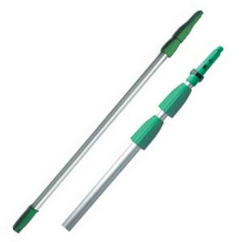
Extension poles are very helpful reaching high places requiring cleaning. Whilst a ladder is a very good tool, an extension pole allows you to reach places where:
- Speed is required
- Where furniture cannot be moved to place a ladder
- Where the floor may not be level or stable.
Ladder
A ladder is a great tool to reach high areas on windows. Many hotel windows are quite large and may go from the floor to the ceiling. By having a small step ladder or even a higher one may be beneficial and a lot safer than standing on tables or chairs.

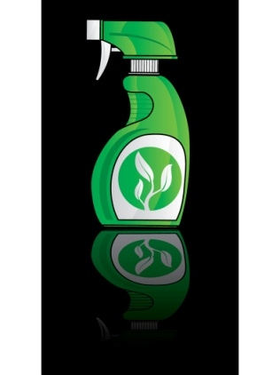
Cleaning products
There is a whole range of cleaning products that can be used.
This can include:
- Commercial window cleaning agents
- Homemade window cleaning liquids.

3.3 Prepare work site

Steps to prepare work site
When preparing to clean, it is vital that the area in which you are going to clean is free from any obstacles that may either get in your way or may get covered in cleaning products or water.
Remove any items off a glass surface, if you are dealing with a coffee table.
Remove any furniture away from windows and unplug any items (electrical cords for lamps) that may get in the way of your walking or ladder areas.
Please refer to introduction for detailed information relating to how to prepare a work site prior to cleaning.

3.4 Clean glass areas

Cleaning a window

Scrubbing
Look carefully at a glass surface before you start to clean. Look for things like scratches, cracks, chips, hard water spots, paint, stucco, silicone or cement. This will give you a good idea of how hard to scrub, or whether or not you will need a window scraper to remove the hard to move items.
If the glass is especially dirty it is recommended to give it a pre-wash. Using your scrubber or a natural sponge, soak the entire window. Then use your squeegee to remove the dirty water.
Now that the majority of dirt is off the glass you can give your window another inspection. Rewet the window and begin to scrub. When scrubbing a window, start with the edges. Scrub back and forth, up and down along each edge. Then, start scrubbing from the top and work your way down to the bottom using small circular motions. Use caution when pressing on any glass. Windows can take quite a bit of pressure, but if the glass is thin or the integrity has been weakened due to deep scratches or cracks, it could break.
If you find that there is debris that will not come off with normal scrubbing, you may have to use chemicals, solvents or a scraper. If you are cleaning non tempered glass, a window scraper is usually safe to use and will remove 98% of all stubborn debris.


Scraping
- Wet the window
- Find a corner to test the scraper out on.
- Scrape in a forward motion three or four times in the same spot.
If it feels and sounds smooth on the third or fourth scrape and there is no scratching, you’re safe to continue with the rest of the window.
If it sounds and feels like the scraper is sliding across sand paper, and continues to sound this way even after the third or fourth scrape, do not scrape the rest of the window. The sandpaper-like sound indicates that this may be flawed or tempered glass that contains raised imperfections.
If tempered or regular glass that contains raised imperfections is scraped, it will cause scratches in the glass.
Once you have determined that it’s safe to scrape the glass, finish the whole window:
- Start with the edges
- Scrape from the inside of the window towards the outside edge
- Work all the way around the window with a one to two inch pattern
- After the edges are scraped, start from the top and work your way towards the bottom
- Scrape in a straight pattern of about four to five inches while overlapping each time
- If the window starts to dry out before your finished, wet it again and then continue where you left off.

Using a squeegee
You should start out learning to squeegee the window from side to side. It is much easier than starting from the top and pulling down. The majority of the windows you clean on a normal basis should be cleaned this way.

The entire window should be wet with soapy water. Determine which side of the window you will be starting on. This may depend on whether you are right or left handed. Take one of the window cleaning towels and wrap you index finger. If you are right handed, wipe the entire right hand edge of the window. Make sure it is completely dry. You may have to move the towel around to a dry spot in the process. Now do the same with the top edge of the window. This will help keep water from dripping down on your window after you squeegee it.
Now that the side and top edges are dry, take your squeegee in hand. Place the rubber blade at the top of the dry right hand edge. As you start to pull it across the window, pull the top of the channel out first so that you can maintain an angle of about 15 to 20 degrees. Pull the squeegee all the way over to the opposite side of the window.
Using your towel, wipe the squeegee blade completely free from water. Also check to see if the side and top edge is still dry. If not give them a quick wipe so that they stay dry. Repeat the same step to finish the lower half of the window.
Now that the window has been squeegeed off, you will need to wipe the edges. This is also known as detailing. It is very important to wipe all the remaining water from the edges in order to get a crisp, flawless finished look.
Cleaning a mirror
Mirrors can be difficult to clean as they may be located in hard to reach places or have substantial frames that may be difficult to clean around. Quite often when cleaning a window streaks, specks or dirt may remain.
Following are simple steps to use when cleaning a window:
- Use a glass cleaning product or combination of white or distilled vinegar and warm water
- Find newspaper to use as your cleaning cloth
- Crumple the newspaper into usable sizes
- Clean the mirror first to remove any heavy dirt or marks
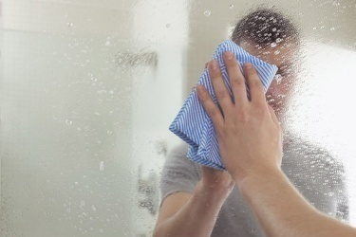
- Use plain water to do the pre-cleaning. Use a cloth with a tight weave, which is more soft and non-abrasive
- Dip the newspaper into the vinegar water solution after pre-cleaning is finished. Rub the newspaper in slow circles across the mirror
- Cover the entire surface of the mirror
- Go over the wet areas with a dry portion of newspaper. This will leave the mirror dry and keep drip marks from drying onto the surface.

Cleaning a glass coffee table
Glass coffee tables are commonly found in hotels. As they are used on a regular basis, they easily attract dust, dirt, hand prints and stains left by crockery and cutlery. Juice glasses and coffee cups are normal culprits for leaving marks.
Simple steps to follow when cleaning a coffee table include:
- Take all items off the coffee table including flowers, ashtrays, magazines and newspapers
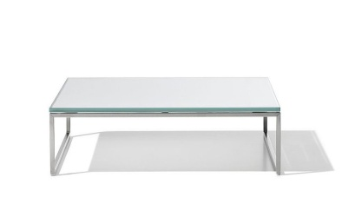
- Wipe the table with a clean dry cloth to remove any dry substances
- Spray a glass cleaner or water on the top of the table
- Scrub the table with a cloth to remove any hard to get stains
- Clean and dry the table with a dry cloth or newspaper.

3.5 Tidy work site

Considerations
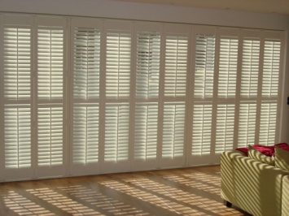
- Remove all cleaning equipment and products
- Ensure all surfaces are clean and dry. This is especially applies to floors which may become dirty or wet
- Return all furniture to their original spots
- Plug in all electrical appliances, especially lights and lamps, that were unplugged as part of the cleaning process
- Return any items to coffee tables
- In the event of windows, return any shades or shutters to their correct position.
Please refer to introduction for detailed information relating to tidying a work site after the completion of work.

3.6 Clean, check and store equipment and chemicals

Steps
- Please place any used cloths in a suitable place for cleaning
- Place all used newspaper pieces in the rubbish bin
- Please ensure all pieces of equipment has been cleaned out of all detergents, residual dirt and other waste products, then placed back in a suitable location for further use
- Place all chemicals and other substances used in a storage area out of reach of children.
Please refer to introduction for detailed information relating to cleaning, checking and storing equipment and chemicals.

Work Projects
It is a requirement of this Unit you complete Work Projects as advised by your Trainer. You must submit documentation, suitable evidence or other relevant proof of completion of the project to your Trainer by the agreed date.
3.1 To fulfil the requirements of this Work Project you are asked to research:
- Uses of glass.
3.2 To fulfil the requirements of this Work Project you are asked to research appropriate equipment and chemicals used to clean glass including:
- Types of equipment
- Cleaning products used.
3.3 To fulfil the requirements of this Work Project you are asked to research:
- Steps taken to prepare work site.
3.4 To fulfil the requirements of this Work Project you are asked to research how to clean glass including steps taken to:
- Clean a window
- Clean a mirror
- Clean a glass coffee table.
3.5 To fulfil the requirements of this Work Project you are asked to research:
- Steps taken to tidy work site after cleaning has taken place.
3.6 To fulfil the requirements of this Work Project you are asked to research:
- Steps taken to clean, check and store equipment and chemicals.

Summary

Apply glass surfaces cleaning techniques
Assess glass area to be cleaned
Types of glass.
Select appropriate equipment and chemicals
Equipment
Cleaning products.
Prepare work site
Steps to prepare work site.
Clean upholstery
Cleaning a window
Cleaning a mirror
Cleaning a glass coffee table.
Tidy work site
Considerations.
Clean , check and store equipment and chemicals
Steps.

Element 4:
Apply ceilings, surfaces and fittings cleaning techniques

4.1 Assess ceilings, surfaces and fittings areas to be cleaned

Types of ceilings, surfaces and fittings
This section looks at the greatest variety of cleaning performed by a public area attendant. It involves various cleaning procedures, equipment and chemicals.
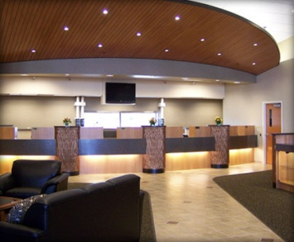
In essence the following needs to be cleaned.
Ceilings
This can include all walls and ceilings:
- Painted
- Wooden
- Wallpaper.
This also includes skirting boards that highlight the separation of walls to ceilings and floors.
Surfaces
This can relate to any 'surface' in a public area including:
- All furniture including fridges, tables, cupboards, ledges, bookshelves and desks to name a few(excluding leather and fabric covered furniture previously discussed)
- Lights and lamps
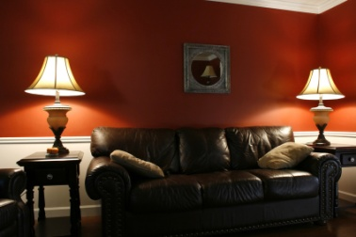
- Decorations and flower vases
- Public bathrooms including vanities, toilets and public showers
- Rubbish bins
- Fixtures refer to items that are attached including heaters, air conditioners and lights
Fittings
A fitting refers to taps, pipes and electrical aspects of a public space.

4.2 Select appropriate equipment and chemicals

Equipment
There is a great deal of equipment that can be used to clean ceilings, surfaces and fittings. These are listed below. For greater explanation please refer to the introduction section of the manual.
- Mops
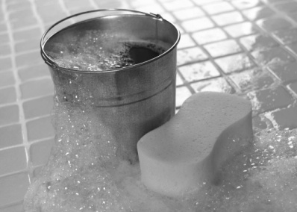
- Brooms and brushes
- Cloths and sponges
- Buckets
- Garbage receptacles
- Gloves
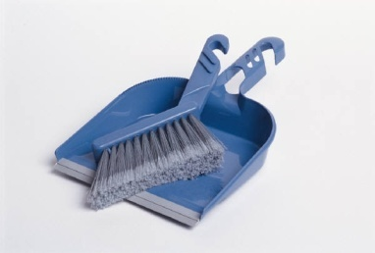
- Cleaning warning signs
- Personal protective equipment
- Dust pans
- Vacuum cleaners
- Equipment complimentary items.

Cleaning products
There is a great deal of cleaning products that can be used when cleaning ceilings, walls, surfaces and fittings. These are listed in the Introduction section of the manual.

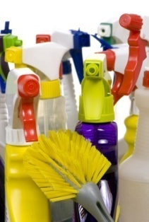
4.3 Prepare work site

Steps to prepare work site
When preparing the work site it is important to remember to:
- Conduct work during quiet times
- Consider safety – remove any items that may be considered a safety hazard when cleaning. This includes electrical cords of any light, lamps or equipment
- Ensure all items are removed from the cleaning area
- Keep all equipment and cleaning products close at hand and out of traffic areas and the reach of customers
- Have all ‘cleaning in progress’ signs ready and visible to customers
- Allow ample time for drying before customers will be using the area.
Please refer to introduction for detailed information relating to how to prepare a work site prior to cleaning.

4.4 Clean ceilings, surfaces and fittings

Dusting and polishing
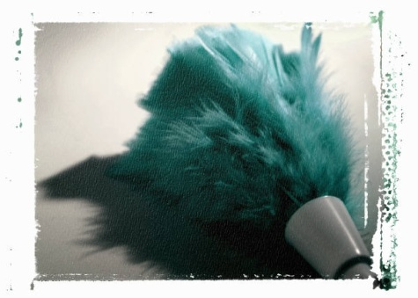
The main purpose of dusting is to collect small particles of dust.
The main purpose of polishing is to clean the item and leave a shiny, reflecting finish.
Dusting may be done with a duster or a damp lint-free cloth.
It is important to use common sense when choosing which piece of equipment to dust with. Don’t use a damp cloth if the moisture could ruin the object being cleaned and remember to change the cloth when soiled.
Your on-the-job training, which will probably include being teamed up with an experienced room attendant for a couple of days, will provide all the workplace guidance you need in this regard.
When polishing an item, make sure to:
- Spray the cleaning agent onto the cloth - not onto the surface to be cleaned
- Buff the surface after cleaning to remove any streaks.
When dusting and polishing, it is best to start in one spot and work around the area, say, in a clockwise direction. This routine should be followed in each instance. Some small items may need to be picked up in order to dust or polish underneath.
The following areas will need either dusting or polishing:
- Air conditioning vents
- Doors – including top ledge and handles
- Picture frames – facing glass as well as frame
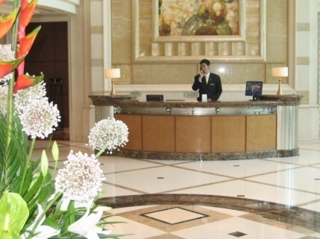
- Mirrors – frame and mirror
- Skirting boards
- Windows – glass and frames
- Window sills
- Walls – check for cobwebs and marks
- Lamps – base, shade and cord
- Telephone – main unit and hand receiver
- Seat furniture – don’t forget to remove cushions and check sides, legs, back and underneath
- All furniture – top, sides, legs, and underneath each item.

Vacuuming
All carpeted areas should be vacuumed and many non-carpeted areas including wooden, tiled or linoleum floors may also require vacuuming.
It is essential that all surfaces are clean and free from dirt, dust and other items
Any stains on carpeted areas should be removed using the appropriate stain removal method for your property that relates specifically to the type of carpet, the active ingredients of the chemical and the type of stain. Where this does not remove the stain, a maintenance report may need to be completed, or the supervisor notified.
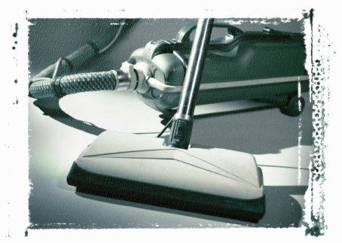
Try to vacuum the area starting at the furthest corner from the door and work back toward the exit.
Ensure you vacuum around and under all furniture.
Particular attention should be placed on the corners of the room, including the skirting boards.
To avoid injury when vacuuming, bend your knees when cleaning under items.
Try to avoid ‘bending over’ the machine. Keep it behind you where possible, moving it forward as you vacuum from a point furthest from the room entry door towards the entrance door of the room.

Cleaning public bathrooms
Cleaning vanity areas
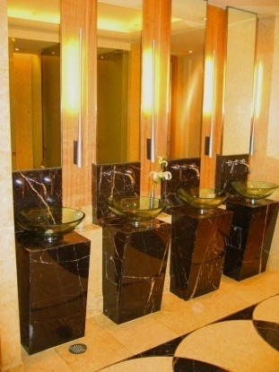
The vanity area is normally the most used area in a rest room.
The vanity area normally includes:
- Bathroom bench
- Basins
- Taps
- Mirror
- Handtowels
- Amenities
- Soap containers.
Similar to when cleaning most surfaces, always wear protective gloves when cleaning the vanity/washing area.

The recommended steps are:
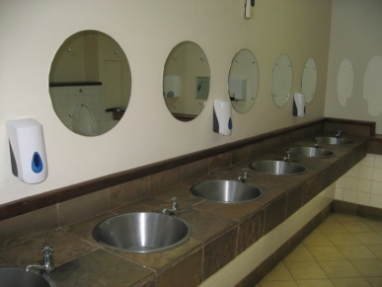
- Clean and dry shelves
- Scrub hand basin, rinse, then dry and polish with clean cloth – check plughole
- Polish fittings and taps
- Clean and dry wall tiles
- Clean, dry and polish bench top
- Clean and polish mirror
- Check under vanity for cleanliness – cobwebs, etc
- Replenish stock – soap, tissues, facial items, shower caps, water
- Replenish towels – paper or linen
- Conduct final check.

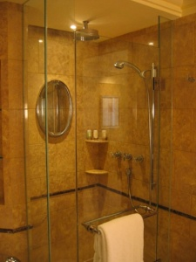
Cleaning public area showers
Some hospitality organisations will provide public shower facilities. This may include golf clubhouses or an area close to pools or beach at a resort allowing guests to refresh without having to return to their rooms.
Always wear protective gloves when cleaning a shower.
The shower can be effectively cleaned as follows:
- Wet shower basin and sides
- Clean tiles and floor – check plughole for foreign matter
- Clean shower curtain – check pole is clean and all hooks are in place and working
- Rinse walls and floor thoroughly
- Polish fittings
- Replenish supplies – shampoo, conditioner and soap
- Conduct final inspection – leave shower curtain neat and to one side.

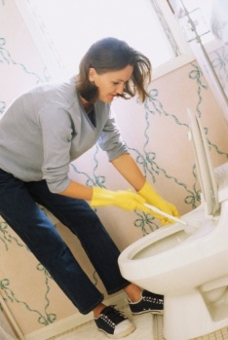
Cleaning toilets
The following steps are effective when:
- Flush toilet to wet sides of bowl
- Pour in cleanser – leave to soak: continue with other work
- Wash lid and dry – both sides and near back hinges
- Wash seat and dry – both sides and near back hinges
- Wash outsides of the bowl and dry
- Wash and dry water holding unit and polish button
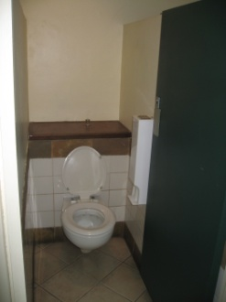
- Scour bowl thoroughly – use a toilet brush
- Flush toilet a number of times to wash away dirt and residue
- Place a hygiene strip over the closed toilet lid
- Conduct final inspection – leave lid down when thoroughly cleaned.
Take a second to recheck that the toilet is clean. This includes the lid and seats, on both sides.
It is also important to ensure any chemicals are removed from toilet surfaces as this cause discomfort if coming in contact with the skin of guests.

Cleaning bins
You should always wear protective gloves when cleaning the bin and should be extra careful when handling the bin as many hazardous items may have been thrown out by the guest – broken glass, razor blades, syringes to mention a few.
Always be vigilant for items that could cause any health or safety risk.
Broken glassware or bottles should be wrapped up in newspaper and disposed of separately and safely.
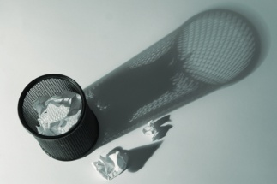
Waste bins should be properly cleaned by:
- Tying the bin liner around the rubbish or emptying the bin directly into your waste bag on the trolley. Remove larger and non-dangerous by hand to facilitate this process where applicable
- Spraying bin with appropriate multi-purpose cleaner, inside and out
- Cleaning with the appropriate cloth.
Fit a new bin liner in the manner approved by the establishment.

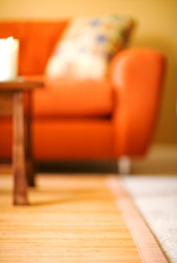
4.5 Tidy work site

Considerations
At the completion of cleaning it is important to ensure the public area is left in a clean and tidy state.
When tidying a work area, always think ‘If I was a customer, would I like the appearance of this public area?”
In essence, there should be no trace of any cleaning activity conducted and should be ready for use by any customer.
Please refer to introduction for detailed information relating to tidying a work site after the completion of work.

4.6 Clean, check and store equipment and chemicals

Steps
- Please place any used cloths in a suitable place for cleaning
- Place all used newspaper pieces in the rubbish bin
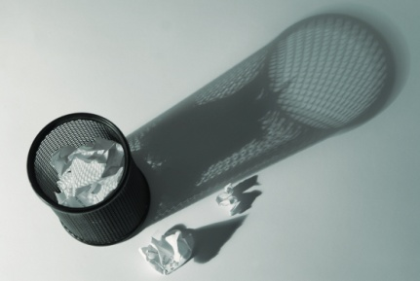
- Ensure any rubbish taken from rubbish bins are placed in the external rubbish areas with recycling functions conducted in line with company policy
- Please ensure all pieces of equipment has been cleaned out of all detergents, residual dirt and other waste products, then placed back in a suitable location for further use
- Place all chemicals and other substances used in a storage area out of reach of children.
Please refer to introduction for detailed information relating to cleaning, checking and storing equipment and chemicals.

Work Projects
It is a requirement of this Unit you complete Work Projects as advised by your Trainer. You must submit documentation, suitable evidence or other relevant proof of completion of the project to your Trainer by the agreed date.
4.1 To fulfil the requirements of this Work Project you are asked to research:
- Types of ceilings, surfaces and fittings.
4.2 To fulfil the requirements of this Work Project you are asked to research appropriate equipment and chemicals used to clean ceilings, surfaces and fittings including:
- Types of equipment
- Cleaning products used.
4.3 To fulfil the requirements of this Work Project you are asked to research:
- Steps taken to prepare work site.
4.4 To fulfil the requirements of this Work Project you are asked to research how to clean ceilings, surfaces and fittings including steps taken to:
- Dust and polish
- Vacuum
- Clean public bathrooms
- Clean bins.
4.5 To fulfil the requirements of this Work Project you are asked to research:
- Steps taken to tidy work site after cleaning has taken place.
4.6 To fulfil the requirements of this Work Project you are asked to research:
- Steps taken to clean, check and store equipment and chemicals.

Summary

Apply ceilings, surfaces and fittings cleaning techniques
Assess ceilings, surfaces and fittings areas to be cleaned
Types of ceilings, surfaces and fittings.
Select appropriate equipment and chemicals
Equipment
Cleaning products.
Prepare work site
Steps to prepare work site.
Clean ceilings, surfaces and fittings
Dusting and polishing
Vacuuming
Cleaning public bathrooms
Cleaning bins.
Tidy work site
Considerations.
Clean , check and store equipment and chemicals
Steps.

Element 5:
Apply wet area cleaning techniques

5.1 Assess wet areas to be cleaned

What is wet area cleaning
There are many public areas in a hotel that contain wet areas. These are floor areas that can be classified as areas that either:
- Commonly have wet surfaces
- Require water to clean them.
The types of surfaces that are usually wet or require water to clean them include:
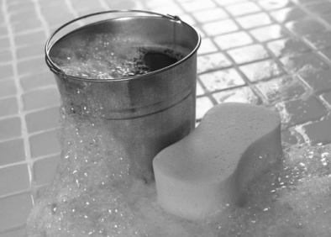
- Wood
- Carpet
- Marble
- Rubber
- Tiles
- Concrete
- Vinyl.
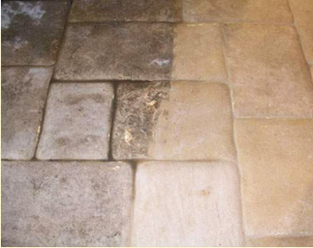
Like the process involved in assessing wet areas to be cleaned, there are some points to keep in mind:
- When should it be cleaned routinely?
- When is an ‘immediate clean required?
- When is the most appropriate time to clean it to keep customer disruption to a minimum?
- What do I need to clean it?
- How do I clean it?

5.2 Select appropriate equipment and chemicals

Equipment
When deciding the best equipment to clean a wet area or using a wet cleaning method, the type of surface to be cleaned is important.
There is a great deal of equipment that can be used to clean wet areas. These are listed below. For greater explanation please refer to the introduction section of the manual.
- Mops

- Brooms and brushes
- Cloths and sponges
- Buckets
- Carpet shampoo machines
- Polishers
- Scrubbing machines
- Floor machines.

Cleaning products
There is a great deal of cleaning products that can be used when cleaning wet areas or using wet cleaning methods. These are listed in the Introduction section of the manual.


5.3 Prepare work site

Steps to prepare work area
When preparing to clean a floor using a wet method is to ensure the floor area to be cleaned is free from any furniture or other objects.
This may involve stacking tables and chairs to a side, or placing chairs on a table so the floor area is clear.
Normally this type of cleaning is done at night when there are fewer customers in the public areas such as the lobby or when specific outlets are closed, such as the pool area, gymnasium and restaurants.
Please refer to introduction for detailed information relating to how to prepare a work site prior to cleaning.

5.4 Clean wet areas
The most popular and easiest way to clean a floor is through mopping. The steps associated with mopping are identified below.
There are other types of equipment that can be used to clean floors. Each of these will require the operator to follow the manufacturer’s instructions.

Mopping
Floors can become very dirty places and therefore it is important they are cleaned correctly and thoroughly.
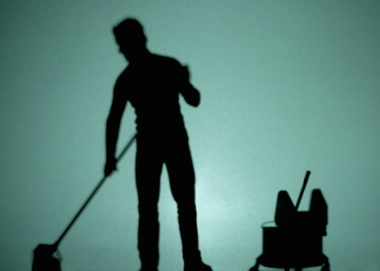
From dirt and dust to the hairsprays, soaps and shampoos, dirt can easily stick around for awhile. While floors are nice to look at when they're clean and sparkling, it doesn't take much to sully them.
Dirt and grime trapped between the tiles and marring the appearance of the grout can make the floor unclean.
Keeping floors clean is essential not only for looking nice, but for sanitary reasons as well.
Steps to mopping
- Remove everything that may be on the floor such as mats, trash cans, and small pieces of furniture
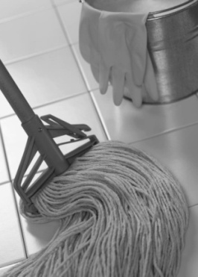
- Sweep the floor to remove dirt, hair, dust, and other debris
- Dissolve detergent into warm water using the manufacturer's instructions for the correct water to detergent ratio
- Pour the solution over the entire floor so that the solution can fill into the grout lines
- Allow the solution to remain on the floor for 15 to 20 minutes
- Scrub the grout with a small medium-bristled brush
- Rinse the floor with a mop dampened with clean water
- Mix a second batch of detergent and water
- Mop the entire floor with the fresh solution
- Rinse the mop with clean water and mop a second time over the floor to rinse it
- Use a squeegee to push residual moisture to one area of the floor before absorbing it with dry towels.

5.5 Tidy work site

Considerations
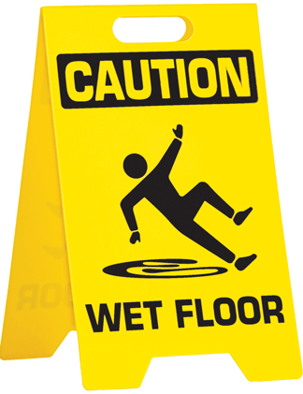
At the completion of cleaning it is important to ensure the public area is left in a clean and tidy state.
More importantly, the surfaces must be dry or safe for customers to use. If the floor is still wet, not only does it attract more dirt by people walking but ca n cause falls and spills.
If it absolutely essential that customers must use an area which contains a wet surface, adequate warning signs and barriers should be put into place.
Once the follow is dry, all equipment and furniture should be returned to their original location and all ‘wet floor’ caution signs removed.
Please refer to introduction for detailed information relating to tidying a work site after the completion of work

5.6 Clean, check and store equipment and chemicals

Steps
- Please place any used cloths in a suitable place for cleaning.
- Place all used newspaper pieces in the rubbish bin.
- Please ensure all pieces of equipment has been cleaned out of all detergents, residual dirt and other waste products, and then placed back in a suitable location for further use.
- Place all chemicals and other substances used in a storage area out of reach of children.
Please refer to introduction for detailed information relating to cleaning, checking and storing equipment and chemicals.

Work Projects
It is a requirement of this Unit you complete Work Projects as advised by your Trainer. You must submit documentation, suitable evidence or other relevant proof of completion of the project to your Trainer by the agreed date.
5.1 To fulfil the requirements of this Work Project you are asked to research:
- Definition of wet area cleaning.
5.2 To fulfil the requirements of this Work Project you are asked to research appropriate equipment and chemicals used to clean wet areas including:
- Types of equipment
- Cleaning products used.
5.3 To fulfil the requirements of this Work Project you are asked to research:
- Steps taken to prepare work site.
5.4 To fulfil the requirements of this Work Project you are asked to research how to clean wet areas including steps taken to:
- Mopping.
5.5 To fulfil the requirements of this Work Project you are asked to research:
- Steps taken to tidy work site after cleaning has taken place.
5.6 To fulfil the requirements of this Work Project you are asked to research:
- Steps taken to clean, check and store equipment and chemicals.

Summary

Apply wet area cleaning techniques
Assess wet areas to be cleaned
What is a wet area?
Select appropriate equipment and chemicals
Equipment
Cleaning products.
Prepare work site
Steps to prepare work site.
Clean wet areas
Mopping.
Tidy work site
Considerations.
Clean , check and store equipment and chemicals
Steps.

Element 6:
Apply pressure washing techniques

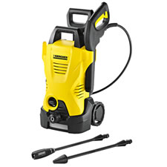
6.1 Assess area to be pressure washed

What is pressure washing
Pressure washing has become a popular cleaning method as it is a quick and effective method which relies on a machine to do the hard work of dirt removal, rather than the exertion of manual labour.
With public areas closed for small periods of time, or not at all, in many hotel outlets, cleaning methods that are quick, effective and simple will always be a preferred option.

6.2 Select appropriate equipment and chemicals

Equipment
Machine
There are many distributors of pressure cleaners each serving their own purposes and have their own points of difference.
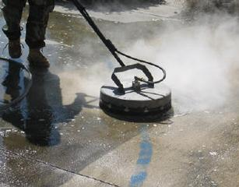
Nozzles & tips
For using pressure washer efficiently you need to choose the correct nozzle or tip.
Most pressure cleaning machines will come with interchangeable spray tips that serve two purposes:
- To lower the pressure and draw the detergent
- Deliver a high pressure rinse at the different spray angles.

Cleaning agents
In essence a pressure cleaning machine will use a mixture of detergent and water to clean and water only to rinse.
Each pressure cleaning machine will come with its own instructions for use and recommended cleaning agents. Use only chemicals and pressure washer cleaning solutions that are approved for pressure washer use.
Whilst there will be many brands of cleaning products, there purpose will remain the same.

Some of these include:
- Film removers – used for removing layers of dirt and grime using a light pressure clean. This includes the cleaning of cars, paths, roads (main driveway) and outdoor areas
- Degreasers - used for removing heavy greaser and industrial cleaning.

6.3 Prepare work site

Steps to prepare work area
When preparing work area using pressure cleaning the main thing to consider is what you are going to clean. This needs to be planned in advance, with any items that could be potentially damaged, either removed or avoided.
Care needs to be taken when pressure cleaning around windows, flowers and garden vegetation, vents, eaves or light fixtures. They can break or become damaged if aimed directly at them.
If you are to clean the edges around windows you need to check for any holes that can allow water to come inside a window or property. In order to prevent this check for any holes, dents and scratches on the frame of the window.
In addition, if you are going to clean around any automated or sliding doors, especially at the entrance of a building, appropriate action including closing, locking and placing barriers to stop water getting in under the doors, should be taken.
Prepare your equipment and again ensure they are out of range of customers and that cleaning is to take place at an appropriate time.
Please refer to introduction for detailed information relating to how to prepare a work site prior to cleaning.
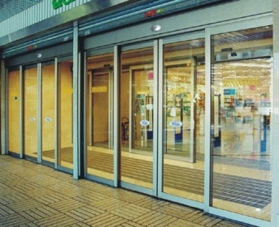

6.4 Clean areas using pressure washer

Cleaning steps
Cleaning steps using a pressure washing machine include:
- Place any safety equipment on including closed shoes, waterproof clothing and safety glasses
- Connect the machine to a water source
- Attach the nozzle or tip and ensure it is correctly attached
- Start the machine
- Test the power of the pressure washer. The best is to start spraying few feet away from any object. Slowly bring your wand to 3-4 feet distance from the surface you want to clean. Move your wand side-to-side a couple of times and check if the surface is clean. If additional cleaning is needed, move your wand gradually closer to the surface. The reason for the gradual cleaning is because pressure washers are extremely powerful and if you start too close you could damage the object instead of cleaning it
- Start to clean using a side to side motion. Keep the nozzle low and start closer to the body and then move the cleaning action further away until you find the right blend of pressure to clean and accuracy
- When washing walls start from the bottom and move up. Remember to take care when cleaning around areas such as windows and lights
- If you are to clean windows, clean from the side. Do not apply a direct ‘face-on’ contact. Check to ensure that water is not leaking inside
- When cleaning the ground, start at lower areas and work your up
- You may need to scrub areas that a pressure cleaner cannot remove stains
- Let the cleaning solution do its work for 20 minutes. This allows for the detergent to start dissolving the dirt, but do not let it sit too long so that it dries out
- When ready to rinse start at the top and work towards the bottom until entire area is detergent free.
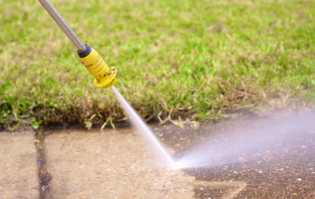

6.5 Tidy work site


Considerations
At the completion of cleaning it is important to ensure the public area is left in a clean and tidy state.
More importantly, the surfaces must be dry or safe for customers to use. If the floor is still wet, not only does it attract more dirt by people walking but ca n cause falls and spills.
If it absolutely essential that customers must use an area which contains a wet surface, adequate warning signs and barriers should be put into place.
Once the follow is dry, all equipment and furniture should be returned to their original location and all ‘wet floor’ caution signs removed.
Please refer to introduction for detailed information relating to tidying a work site after the completion of work.

6.6 Clean, check and store equipment and chemicals

Steps
- Please ensure all pieces of equipment has been cleaned out of all detergents, residual dirt and other waste products, then placed back in a suitable location for further use
- Place all chemicals and other substances used in a storage area out of reach of children.
Please refer to introduction for detailed information relating to cleaning, checking and storing equipment and chemicals.

Work Projects
It is a requirement of this Unit you complete Work Projects as advised by your Trainer. You must submit documentation, suitable evidence or other relevant proof of completion of the project to your Trainer by the agreed date.
6.1 To fulfil the requirements of this Work Project you are asked to research:
- Definition of pressure washing.
6.2 To fulfil the requirements of this Work Project you are asked to research appropriate equipment and chemicals used in pressure washing including:
- Types of equipment
- Cleaning products used.
6.3 To fulfil the requirements of this Work Project you are asked to research:
- Steps taken to prepare work site.
6.4 To fulfil the requirements of this Work Project you are asked to research how to clean using pressure washing including steps taken to:
- Conduct pressure washing.
6.5 To fulfil the requirements of this Work Project you are asked to research:
- Steps taken to tidy work site after cleaning has taken place.
6.6 To fulfil the requirements of this Work Project you are asked to research:
- Steps taken to clean, check and store equipment and chemicals.

Summary

Apply pressure washing techniques
Assess wet areas to be pressure washed
What is pressure washing?
Select appropriate equipment and chemicals
Equipment
Cleaning products.
Prepare work site
Steps to prepare work site.
Clean areas using pressure washer
Cleaning steps.
Tidy work site
Considerations.
Clean , check and store equipment and chemicals
Steps.

Element 7:
Apply high level cleaning techniques

7.1 Assess high level areas to be cleaned

Types of high level cleaning
As the title suggest high level cleaning is cleaning of items which are ‘at a high level’ above the ground. High level cleaning is more difficult that other types of cleaning identified to date and in most cases requires the use of specialised staff to perform these cleaning duties.
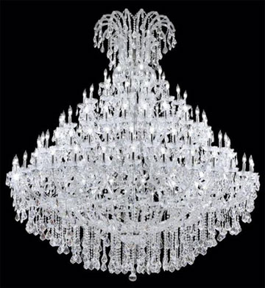
Types of high level cleaning include areas such as:
- High level lights and chandeliers
- High ceilings and ceiling beams
- High exhaust extraction fans in kitchens
- Cleaning external windows on high rise hotels
- Skylights
- Sculptures
- Foyer glass
- Signs and banners.

7.2 Select appropriate equipment and chemicals

Equipment
As stated above, depending on the height of the item to be cleaned, it can be done by hotel staff or it may require the expertise of a professional.
If the job is to be performed by a staff member, common equipment includes:
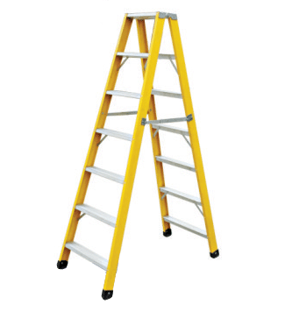
- Ladders
- Safety ropes
- Extension poles
- High pressure cleaning equipment
- Cranes – this normally requires specialised staff to operate.
All of these items have been discussed in detail in previous sections.

7.3 Prepare work site

Steps to prepare work site
Depending on the area to clean, safety is the key. The most important aspect is ensuring that equipment used to raise you to a certain height is safe, grounded and placed on a secure and level ground.
You need to prepare any equipment and cleaning materials in a manner that allows for each access when you are ‘at height’
This may require the use of a cleaning tool belt containing adequate cloths and cleaning agents.
You may also need to rope off the area so that customers and staff do not wander into the space and either come in contact with ladders or have items fall on them.
It is also wise to have another person with you to:
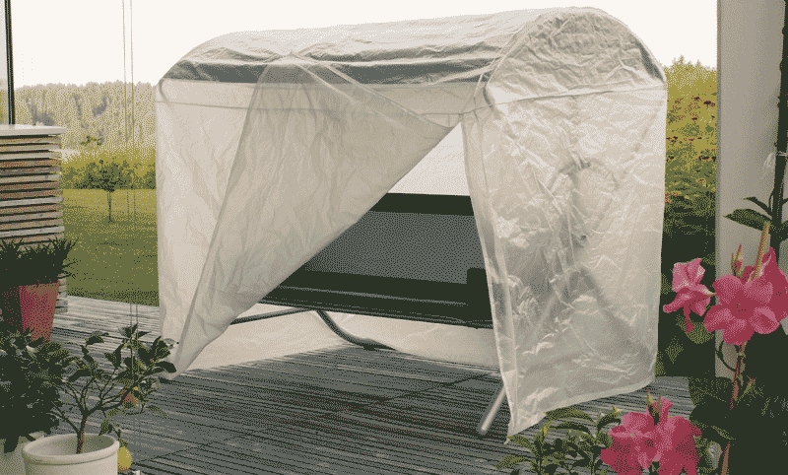
- Support the ladder
- Pass items up and down
- Pass comment
- Direct passers-by.
When cleaning at height, it is natural that any dirty items will fall down. Think about the furniture directly under where cleaning will take place and make necessary arrangements including:
- Removing the item
- Covering the item with sheets or other protective materials.
Please refer to introduction for detailed information relating to how to prepare a work site prior to cleaning.

7.4 Clean high level areas

Considerations
Depending on the type of cleaning, please proceed as explained in previous sections.
For further comment, techniques and steps involved in cleaning, please refer to the appropriate type of cleaning indentified in the manual.

7.5 Tidy work site

Considerations
At the completion of cleaning it is important to ensure the public area is left in a clean and tidy state.
You may be required to:
- Remove to coverings you have placed on furniture
- Conduct a vacuum, sweep or mop of the area
- Ensure the floor is dry
- Once the follow is dry, all equipment and furniture should be returned to their original location and all ‘wet floor’ caution signs removed.
Please refer to introduction for detailed information relating to tidying a work site after the completion of work.

7.6 Clean, check and store equipment and chemicals

Steps
- Please ensure all pieces of equipment has been cleaned out of all detergents, residual dirt and other waste products, then placed back in a suitable location for further use
- Place all chemicals and other substances used in a storage area out of reach of children.
Please refer to introduction for detailed information relating to cleaning, checking and storing equipment and chemicals.

Work Projects
It is a requirement of this Unit you complete Work Projects as advised by your Trainer. You must submit documentation, suitable evidence or other relevant proof of completion of the project to your Trainer by the agreed date.
7.1 To fulfil the requirements of this Work Project you are asked to research:
- Types of high level cleaning.
7.2 To fulfil the requirements of this Work Project you are asked to research appropriate equipment and chemicals used in high level cleaning including:
- Types of equipment.
7.3 To fulfil the requirements of this Work Project you are asked to research:
- Steps taken to prepare work site.
7.4 To fulfil the requirements of this Work Project you are asked to research how to undertake high level cleaning including:
- Considerations.
7.5 To fulfil the requirements of this Work Project you are asked to research:
- Steps taken to tidy work site after cleaning has taken place.
7.6 To fulfil the requirements of this Work Project you are asked to research:
- Steps taken to clean, check and store equipment and chemicals.

Summary

Apply high level cleaning techniques
Assess high level areas to be cleaned
Types of high level cleaning.
Select appropriate equipment and chemicals
Equipment.
Prepare work site
Steps to prepare work site.
Clean high level areas
Considerations.
Tidy work site
Considerations.
Clean , check and store equipment and chemicals
Steps.

Presentation of written work

1. Introduction
It is important for students to present carefully prepared written work. Written presentation in industry must be professional in appearance and accurate in content. If students develop good writing skills whilst studying, they are able to easily transfer those skills to the workplace.

2. Style

Students should write in a style that is simple and concise. Short sentences and paragraphs are easier to read and understand. It helps to write a plan and at least one draft of the written work so that the final product will be well organised. The points presented will then follow a logical sequence and be relevant. Students should frequently refer to the question asked, to keep ‘on track’. Teachers recognise and are critical of work that does not answer the question, or is ‘padded’ with irrelevant material. In summary, remember to:
- Plan ahead
- Be clear and concise
- Answer the question
- Proofread the final draft.

3. Presenting Written Work
Types of written work
Students may be asked to write:
- Short and long reports
- Essays
- Records of interviews
- Questionnaires
- Business letters
- Resumes.
Format
All written work should be presented on A4 paper, single-sided with a left-hand margin. If work is word-processed, one-and-a-half or double spacing should be used. Handwritten work must be legible and should also be well spaced to allow for ease of reading. New paragraphs should not be indented but should be separated by a space. Pages must be numbered. If headings are also to be numbered, students should use a logical and sequential system of numbering.
Cover Sheet
All written work should be submitted with a cover sheet stapled to the front that contains:
- The student’s name and student number
- The name of the class/unit
- The due date of the work
- The title of the work
- The teacher’s name
- A signed declaration that the work does not involve plagiarism.
Keeping a Copy
Students must keep a copy of the written work in case it is lost. This rarely happens but it can be disastrous if a copy has not been kept.
Inclusive language
This means language that includes every section of the population. For instance, if a student were to write ‘A nurse is responsible for the patients in her care at all times’ it would be implying that all nurses are female and would be excluding male nurses.
Examples of appropriate language are shown on the right:
Mankind | Humankind
Barman/maid | Bar attendant
Host/hostess | Host
Waiter/waitress | Waiter or waiting staff

Recommended reading
Casado, Matt A.; 2011 (2nd edition); Housekeeping Management (Course Smart); Wiley
Jones, Thomas J. A. 2007 (5th edition); Professional Management of Housekeeping Operations; Wiley
Nitschke, Aleta A. 2008 (3rd edition); Managing Housekeeping Operations; Educational Institute of the American Hotel Motel Association
Kappa, Margaret M., 1997 (2nd edition); Housekeeping Management; Educational Institute of the American Hotel Motel Association
O'Fallon, Michael J.; 2010 (5th edition); Hotel Management and Operations; Wiley

Trainee evaluation sheet

Clean public areas, facilities and equipment
The following statements are about the competency you have just completed.
Please tick the appropriate box | Agree | Don’t Know | Do Not Agree | Does Not Apply
There was too much in this competency to cover without rushing.
Most of the competency seemed relevant to me.
The competency was at the right level for me.
I got enough help from my trainer.
The amount of activities was sufficient.
The competency allowed me to use my own initiative.
My training was well-organized.
My trainer had time to answer my questions.
I understood how I was going to be assessed.
I was given enough time to practice.
My trainer feedback was useful.
Enough equipment was available and it worked well.
The activities were too hard for me.

The best things about this unit were:

The worst things about this unit were:

The things you should change in this unit are:

Trainee self-assessment checklist
As an indicator to your Trainer/Assessor of your readiness for assessment in this unit please complete the following and hand to your Trainer/Assessor.

Clean public areas, facilities and equipment
 |  | Yes | No*
Element 1: Apply leather upholstery cleaning techniques
1.1 | Describe the services delivered by a room attendant
1.2 | Locate the position of room attendants within the enterprise
1.3 | Identify the personal characteristics required of a room attendant
1.4 | Describe grooming and personal presentation standards for a room attendant
1.5 | Interpret enterprise policies and procedures for the provision of housekeeping services
1.6 | Identify and explain the role of communication in the provision of housekeeping services
Element 2: Apply fabric upholstery cleaning techniques
2.1 | Assess fabric upholstery to be cleaned
2.2 | Select appropriate equipment and chemicals
2.3 | Prepare work site
2.4 | Clean upholstery
2.5 | Tidy work site
2.6 | Clean, check and store equipment and chemicals
Element 3: Apply glass surfaces cleaning techniques
3.1 | Assess glass areas to be cleaned
3.2 | Select appropriate equipment and chemicals
3.3 | Prepare work site
3.4 | Clean glass areas
3.5 | Tidy work site
3.6 | Clean, check and store equipment and chemicals
Element 4: Apply ceilings, surfaces and fittings cleaning techniques
4.1 | Assess ceilings, surfaces and fittings areas to be cleaned
4.2 | Select appropriate equipment and chemicals
4.3 | Prepare work site
4.4 | Clean ceilings, surfaces and fittings
4.5 | Tidy work site
4.6 | Clean, check and store equipment and chemicals
Element 5: Apply wet area cleaning techniques
5.1 | Follow in-house requirements and policies in relation to room cleaning
5.2 | Clean fixtures and fittings
5.3 | Vacuum floors and other areas
5.4 | Clean kitchenette area, where applicable
5.5 | Replenish guest supplies
5.6 | Check operational readiness of all items and equipment
Element 6: Apply pressure washing techniques
6.1 | Assess area to be pressure washed
6.2 | Select appropriate equipment and chemicals
6.3 | Prepare work site
6.4 | Clean areas using pressure washer
6.5 | Tidy work site
6.6 | Clean, check and store equipment and chemicals
Element 7: Apply high level cleaning techniques
7.1 | Assess high level areas to be cleaned
7.2 | Select appropriate equipment and chemicals
7.3 | Prepare work site
7.4 | Clean high level areas
7.5 | Tidy work site
7.6 | Clean, check and store equipment and chemicals
Statement by Trainee:
I believe I am ready to be assessed on the following as indicated above:
Signed: _____________________________ | Date: ____________

Note:
For all boxes where a No* is ticked, please provide details of the extra steps or work you need to do to become ready for assessment.





